

Training Manual
For
Technical Support

By Kirby C. Cobb

January 1st, 2009

Pearson
19500 Bulverde Rd.
San Antonio, TX 78259

Microsoft, Windows, FoxPro, SQL Server, and Visual Basic are registered trademarks of Microsoft Corporation. Java is a trademark of Sun Microsystems, Inc. Macintosh, Mac, QuickTime, and Mac OS are registered trademarks of Apple Computers, Inc. ASSIST is a trademark of Pearson Education.
Table of Contents

Section One: Introduction

Section Two: ASSIST™ Computer Software
- BASC-2 and PRQ ASSIST
- BASC Monitor
- BASC-2 POP w/PDA & w/o PDA (Versions 2.0, 3.0)
- BASC-2 BESS
- BASC-2 Progress Monitoring
- BOT-2 ASSIST
- CASL ASSIST
- CDM-R ASSIST
- DIAL-3 ASSIST
- EVT ASSIST
- GFTA-2\KLPA-2 ASSIST
- GMADE
- GRADE
- KABC ASSIST
- KABC-II ASSIST
- KeyMath-R/NU ASSIST
- KeyMath-3 and ER ASSIST
- KTEA-II ASSIST
- Mullen ASSIST
- OWLS LC\OE ASSIST
- OWLS WE ASSIST
- PIAT-R/NU ASSIST
- PPVT-III ASSIST
- PPVT-4/PPVT-III/EVT/EVT-2 ASSIST
- SSIS ASSIST
- SSRS ASSIST
- Vineland Survey ASSIST
- Vineland Classroom ASSIST
- Vineland Expanded ASSIST
- Vineland SEEC
- Vineland-II Survey\TRF\Expanded ASSIST
- WRMT-R/NU ASSIST

Section Three: Common FoxPro® Issues (Windows® and Macintosh®)

Section Four: Common Visual Basic Issues (Windows)

Section Five: Common Java™ Issues (Windows and Macintosh)

Section Six: Client\Server

Section Seven: Conclusion

Section One

Introduction

Welcome to Pearson! This manual has been developed to help you familiarize yourself with both the products we support, the problems that we encounter, and ways to provide excellent service to our customers that meets and exceeds their expectations.

There are many common issues that we face, as well as some that are not so common. You will have to rely on your own instincts and knowledge to work through some of the more challenging issues that may arise. This manual is not intended to replace the software user manuals or to explain how each application works. Instead, this is designed to give you a basic understanding, or complex depending on the issue, of the problems that can occur and how to reach a resolution.

This manual is divided into six main sections. You are currently in Section One, which contains the introduction to this manual. Section Two introduces you to our family of products that you will be supporting, the system requirements for each, and a brief synopsis of the software’s function. Sections Three, Four, and Five deal with the common issues for each language our products may be written in and how to resolve them. Section Six delves into the world of our Client\Server model and how to implement and support the same. Section Seven is the conclusion of the manual.

This manual is only a guide. Our users will challenge you with a variety of descriptions and errors that may or may not be known. There will always be new issues or calls that you have never received. It is completely acceptable to not have an answer for every problem. With the number of different products combined with the number of different users, there are countless configurations which we have not, and cannot, account for. Using your own knowledge of technology and our products will be vital in troubleshooting and resolving future issues. Do not be afraid to tell a user that you are unsure as to an immediate fix, but that you will find out and get back with them in a timely manner. When this situation arises, you must FOLLOW THROUGH! It is critical to our company image that we keep our promises to users. If you say what you mean and mean what you say, you will almost always have a satisfied customer.

Section Two

ASSIST Computer Software

The primary name for these products is the Automated System for Scoring and Interpreting Standardized Tests, or ASSIST for short. This name is also used to reference the platform that the latest versions of most of our products are built on. Even some products that are not called ASSISTs are still built using the same style and functionality (i.e. GRADE and GMADE). The ASSIST software is designed to aid the clinician, teacher, or diagnostician in obtaining valuable information in assessment in a minimum amount of time. In the past, the test would be administered, the raw scores calculated by hand, and then cross-reference all of the answers with a manual to obtain the results such as T-scores, scaled scores, and percentile rankings. This process can take in upwards of 30 to 45 minutes depending on the test administered. The ASSIST takes that work out of the equation. By entering either raw scores or, in some cases individual item scores, the ASSIST will calculate the data against the selected norm tables and produce a report that summarizes this information. The actual report generated differs from test to test. It is important to note that while the ASSIST does in most cases generate an informative and presentable report; interpretation of the results is still the job of the clinician or a qualified Pearson representative. Understanding and interpreting the results does not fall to technical support.

In the following pages we will touch on the specific tests that currently have an ASSIST available. Also noted will be those products that are built on the ASSIST platform. There will be a brief synopsis of the test itself, followed by the system requirements. The system requirements for this software will vary based on the Operating System that the user is on. Only three requirements are listed for each and each is the minimum acceptable: CPU speed, available RAM, and available disk space. The available RAM requirement means what is left over AFTER the O\S and other TSR applications necessary for the computer have taken their share. The available disk space requirement does not mean the space needed to just load the program. Instead, for Windows based computers, it allows for the Java Runtime Environment (JRE) where applicable, as well as the swap or page file space needed for effective operation of the software. Macintosh computers have the JRE built in and use different methods for virtual memory management. In addition, CPU requirements are not listed for Macintosh computers. This is because as long as the system can run OS 10.3.x or later, then the CPU is of adequate speed. This space requirement is also listed to allow for the database of the application to grow with usage.

The sale of the Pearson scanning division to Scantron Corp. has caused some confusion regarding scanner models. In the past Scantron or NCS were the dividing factors. Since all of these scanners are now under one company, we will refer to them by their model name\number. All scanners must be capable of dual-head and 48-channel reading.

Supported Scanners:
ScanMark ES2260, ScanMark ES2280, OpScan 4, 4u, 4InSight, 6, 8, 10, 21, and 5000i. For the OpScan 21 and 5000i, special conditions apply.

- BASC-2 and PRQ ASSIST

The Behavior Assessment System for Children, 2nd Edition (BASC-2) is a comprehensive set of rating scales and forms including the Teacher Rating Scales (TRS), Parent Rating Scales (PRS), Self-Report of Personality (SRP), Parent Relationship Questionnaire (PRQ), Student Observation System (SOS), and Structured Developmental History (SDH). Together, they help you understand the behaviors and emotions of children and adolescents.

The BASC-2 and PRQ ASSIST comes in many versions, all of which are contained within a single piece of software. An activation key will determine which portions of the application the user has access to. While the BASC-2 and the PRQ are listed together and use the same software, it is important to understand that these products can be used independently. A user does not have to purchase the PRQ to have access to the BASC-2 or vice versa. PRQ can be added to any version of the BASC-2 ASSIST and again, vice versa. Also, while the test references the SOS and SDH forms, the ASSIST software does not score either of these two forms.

The types of BASC-2 that are offered are:
- BASC-2 ASSIST (Hand-entry, local database)
- BASC-2 ASSIST Plus (Hand-entry, local database, advanced reporting options)
- BASC-2 ASSIST\ASSIST Plus Scanning (Same as above with the addition of a scanning component. Scanning is Windows only.)
- BASC-2 ASSIST\ASSIST Plus Client\Server (Same as above with the addition of allowing the user to connect to a SQL Server database located on the same subnet. Either Macintosh or Windows can utilize this version. Scanning is also available for this version, but is still Windows only.)

Windows System Requirements:

Operating System | CPU Speed | Available RAM | Available HDD Space
Windows 2000 | 133 MHz | 64 MB (512 MB with scanning) | 2 GB
Windows XP (All Versions) | 300 MHz | 128 MB (512 MB with scanning) | 2 GB
Windows Vista | 1 GHz | 1 GB (2GB with scanning) | 40 GB

Macintosh System Requirements:

Operating System | Available Ram | Available HDD Space
Macintosh OS 10.3.x (Panther) | 128 MB | 3 GB
Macintosh OS 10.4.x (Tiger) | 512 MB | 4 GB
Macintosh OS 10.5.x (Leopard) | 512 MB | 9 GB
- BASC Monitor

The BASC Monitor for ADHD offers an important bridge between the diagnosis of attention-deficit/hyperactivity disorder (ADHD) and treatment management of the disorder. The BASC Monitor offers an assessment regimen designed to enhance treatment planning and evaluation by more thoroughly surveying the primary symptoms of ADHD in a format that is well suited to repeated assessments. In addition, the BASC Monitor organizes case data over time to help the clinician see relationships between symptoms and treatments. The system may be used with children aged 4 to 18 years, and is a complement to the full BASC (BASC-2) system.

The BASC Monitor is sold in both a single-user and multi-user version. The difference is in database location. This is an older piece of software and it is not in wide-spread use. There are no system requirements listed for this application. This program was written in FoxPro and all systems in operation today are well beyond the needs of this language. The problem may actually be finding a computer slow enough to run the application. This product is Windows only.

- BASC-2 POP w/PDA & w/o PDA (Versions 2.0, 3.0)

The BASC-2 Portable Observation Program (POP) is a screening tool which allows the clinician to record behavioral data on a child electronically. There are no pre-printed forms for this application, but the option exists to allow the user to create their own custom forms from printed materials they may have been given or created in the past. Version 2.0 allowed users to utilize a Personal Digital Assistant (PDA) to schedule and conduct these observations. Due to advancement in PDA technology much of the technology used in 2.0 is now defunct and the decision was made to drop PDA support at this time. Version 3.0 has the same features as 2.0 sans the PDA component and was compiled in a newer version of Java. Macintosh OS 10.5.5 requires the user to be on Version 3.0 as the Java version required for 2.0 has been deprecated.

Windows System Requirements:

Operating System | CPU Speed | Available RAM | Available HDD Space
Windows 2000, Windows XP, Windows Vista | 300 MHz | 128 MB | 1 GB

Macintosh System Requirements:

Operating System | Available RAM | Available HDD Space
Macintosh OS 10.3.x (Panther) | 128 MB | 1 GB
Macintosh OS 10.4.x (Tiger) | 128 MB | 1 GB
Macintosh OS 10.5.x (Leopard) | 128 MB | 1 GB

- BASC-2 BESS ASSIST

The BASC-2 Behavioral and Emotional Screening System offers a reliable, quick, and systematic way to determine behavioral and emotional strengths and weaknesses of children and adolescents in preschool through high school. This comprehensive screening system consists of brief forms that can be completed by teachers, parents, or students. While this product is in the BASC-2 family, it is important to note that this application is completely stand-alone and does not integrate with the BASC-2 ASSIST in any way. Scanning is available for this product but is Windows only.

Windows System Requirements:

Operating System | CPU Speed | Available RAM | Available HDD Space
Windows 2000 | 133 MHz | 64 MB (512 MB with scanning) | 2 GB
Windows XP (All Versions) | 300 MHz | 128 MB (512 MB with scanning) | 2 GB
Windows Vista | 1 GHz | 1 GB (2GB with scanning) | 40 GB

Macintosh System Requirements:

Operating System | Available Ram | Available HDD Space
Macintosh OS 10.3.x (Panther) | 128 MB | 3 GB
Macintosh OS 10.4.x (Tiger) | 512 MB | 4 GB
Macintosh OS 10.5.x (Leopard) | 512 MB | 9 GB

- BASC-2 Progress Monitor ASSIST

The BASC-2 Progress Monitor helps track the effectiveness of BASC-2 interventions that have implemented. Teachers, parents, and/or students use brief, 15-20 item rating forms specific to the behavior being remediated. The forms represent the composite score domains presented on the BASC-2 (e.g., Externalizing Problems, Internalizing Problems, Social Withdrawal and Adaptive Skills). Scanning is available for this product but is Windows only.

Windows System Requirements:

Operating System | CPU Speed | Available RAM | Available HDD Space
Windows 2000 | 133 MHz | 64 MB (512 MB with scanning) | 2 GB
Windows XP (All Versions) | 300 MHz | 128 MB (512 MB with scanning) | 2 GB
Windows Vista | 1 GHz | 1 GB (2GB with scanning) | 40 GB

Macintosh System Requirements:

Operating System | Available Ram | Available HDD Space
Macintosh OS 10.3.x (Panther) | 128 MB | 3 GB
Macintosh OS 10.4.x (Tiger) | 512 MB | 4 GB
Macintosh OS 10.5.x (Leopard) | 512 MB | 9 GB

- BOT-2 ASSIST

The Bruininks-Oseretsky Test of Motor Proficiency, 2nd Edition (BOT-2) assesses the motor proficiency of all students, ranging from those who are normally developing to those with moderate motor-skill deficits. It can also be used for developing and evaluating motor training programs.

Windows System Requirements:

Operating System | CPU Speed | Available RAM | Available HDD Space
Windows 2000 | 133 MHz | 64 MB | 2 GB
Windows XP (All Versions) | 300 MHz | 128 MB | 2 GB
Windows Vista | 1 GHz | 1 GB | 40 GB

Macintosh System Requirements:

Operating System | Available Ram | Available HDD Space
Macintosh OS 10.3.x (Panther) | 128 MB | 3 GB
Macintosh OS 10.4.x (Tiger) | 512 MB | 4 GB
Macintosh OS 10.5.x (Leopard) | 512 MB | 9 GB

- CASL ASSIST

The Comprehensive Assessment of Spoken Language (CASL) is a norm-referenced oral language battery of 15 tests for children and young adults aged 3 through 21 years. Each of the CASL tests is individually administered and is based on a well-defined theory of language. The battery is designed to measure the process of comprehension, expression, and retrieval in four language categories: Lexical\Semantic, Syntactic, Supralinguistic, and Pragmatic.

This application is compiled in version 1.3 of Java and as such may have issues on newer systems. This version of the JRE is required for proper operation. Macintosh computers, where you cannot control the version of Java being used, have a variety of issues with this product.

Windows System Requirements:

Operating System | CPU Speed | Available RAM | Available HDD Space
Windows 2000 | 133 MHz | 64 MB | 50 MB
Windows XP (All Versions) | 300 MHz | 64 MB | 50 MB
Windows Vista | 1 GHz | 512 MB | 150 MB

Macintosh System Requirements:

Operating System | Available Ram | Available HDD Space
Macintosh OS 10.3.x (Panther) | 128 MB | 1 GB
Macintosh OS 10.4.x (Tiger) | 512 MB/ May have issues running | 1 GB/ May have issues running
Macintosh OS 10.5.x (Leopard) | Not Compatible | Not Compatible

- DIAL-3 ASSIST

The Developmental Indicators for the Assessment of Learning – Third Edition (DIAL-3) is an individually administered developmental screening designed to identify young children in need of further diagnostic assessment. DIAL-3 is a 30-minute assessment of motoric, conceptual, and language behaviors demonstrated by children from the ages of 3 years, 0 months (3-0) through 6 years, 11 months (6-11). DIAL-3 items assess developmental skills that are the foundation for academic learning.

The Speed DIAL is designed for sites or situations where a shorter version of the DIAL-3 is desirable. This format consists of ten DIAL-3 items, nine of which cover the entire four-year age span. The screening decision is based only on the total score.
This product is written in FoxPro 2.6a and may have intermittent issues running on newer systems. It has been tested for compatibility with all versions of Windows with success. The Macintosh platform requires that Classic Mode (a virtual install of OS 9.x) be present for this software to run. Native installs of OS 10.x.x do not include Classic Mode. In the case of OS 10.5.x (Leopard) there is no way to install Classic Mode and as such, no way to use this or any other FoxPro applications.

Windows System Requirements:

Operating System | CPU Speed | Available RAM | Available HDD Space
Windows 2000, Windows XP, Windows Vista | 300 MHz | 64 MB | 100 MB

Macintosh System Requirements:

Operating System | Available RAM | Available HDD Space
Macintosh OS 10.3.x (Panther) | 64 MB | 100 MB
Macintosh OS 10.4.x (Tiger) | 64 MB | 100 MB

- EVT ASSIST

The Expressive Vocabulary Test (EVT) is an individually administered norm-referenced assessment of expressive vocabulary and word retrieval for children aged 2 ½ through 90 years. The EVT was co-normed with the Peabody Picture Vocabulary Test – Third Edition (PPVT-III). The EVT measures expressive vocabulary knowledge with two types of items, labeling and synonym. Word retrieval is evaluated by comparing expressive and receptive vocabulary skills using standard score differences between EVT and PPVT-III.

The EVT has been replaced by the EVT-2 but support for the EVT does not sunset until the end of 2nd quarter, 2009. The original EVT test has been incorporated into the new ASSIST for the EVT-2.

This product is written in FoxPro 2.6a and may have intermittent issues running on newer systems. It has been tested for compatibility with all versions of Windows with success. The Macintosh platform requires that Classic Mode (a virtual install of OS 9.x) be present for this software to run. Native installs of OS 10.x.x do not include Classic Mode. In the case of OS 10.5.x (Leopard) there is no way to install Classic Mode and as such, no way to use this or any other FoxPro applications.

Windows System Requirements:

Operating System | CPU Speed | Available RAM | Available HDD Space
Windows 2000, Windows XP, Windows Vista | 300 MHz | 64 MB | 100 MB

Macintosh System Requirements:

Operating System | Available RAM | Available HDD Space
Macintosh OS 10.3.x (Panther) | 64 MB | 100 MB
Macintosh OS 10.4.x (Tiger) | 64 MB | 100 MB

- GFTA-2/KLPA-2 ASSIST
The Goldman-Fristoe Test of Articulation – Second edition provides information about a child’s articulation ability by sampling both spontaneous and imitative sound production. Examinees respond to picture plates and verbal cues from the examiner with single-word answers that demonstrate common speech sounds. Additional sections provide further measures of speech production. This test is used to measure articulation of consonant sounds, determine types of misarticulation, and compare individual performance to national, gender-differentiated norms.
The Kahn-Lewis Phonological Analysis – Second edition (KLPA-2) works with GFTA-2 to give a more comprehensive diagnosis of both articulation and use of phonological processes. This allows for more informed therapy decisions.
The ASSIST product has the ability to score both tests. There is no add-on for this as the product comes ready for both as is. Users can score a GFTA-2 without having to score a KLPA-2. However, a KLPA-2 cannot be scored without a valid GFTA-2 being present. This product was developed in Visual Basic 6 and is not compatible with Macintosh computers.
Windows System Requirements:

Operating System | CPU Speed | Available RAM | Available HDD Space
Windows 2000, Windows XP, Windows Vista | 300 MHz | 128 MB | 100 MB

- GMADE

The Group Mathematics Assessment and Diagnostic Evaluation (GMADE) is a norm-referenced test that measures individual skills in the main areas of math as identified by the National Council of Teachers of Mathematics (NCTM) including Concepts and Communication, Operations and Computation, and Process and Application. This test helps pinpoint areas where students need instruction. Scores include stanines, percentiles, grade equivalents, age equivalents, standard scores, normal curve equivalents, and growth scale values. Two parallel forms at every level, each with fall and spring norms, make it possible to follow progress and monitor growth over time.
This product, though not called an ASSIST, is still built on the ASSIST platform and as such has both the same system requirements and functionality of the ASSISTs.

Windows System Requirements:

Operating System | CPU Speed | Available RAM | Available HDD Space
Windows 2000 | 133 MHz | 64 MB (512 MB with scanning) | 2 GB
Windows XP (All Versions) | 300 MHz | 128 MB (512 MB with scanning) | 2 GB
Windows Vista | 1 GHz | 1 GB (2GB with scanning) | 40 GB

Macintosh System Requirements:

Operating System | Available Ram | Available HDD Space
Macintosh OS 10.3.x (Panther) | 128 MB | 3 GB
Macintosh OS 10.4.x (Tiger) | 512 MB | 4 GB
Macintosh OS 10.5.x (Leopard) | 512 MB | 9 GB

- GRADE

The Group Reading Assessment and Diagnostic Evaluation (GRADE) is a norm-referenced group test that helps teachers confidently assess pre-literacy, emerging reading and core reading skills, plan focused instruction, and document student progress. This assessment provides detailed diagnostic information about individual skill levels, making it possible to identify students who may need further testing and intervention. Two parallel forms at every level, each with fall and spring norms, make it possible to follow progress and monitor growth over time.

This product, though not called an ASSIST, is still built on the ASSIST platform and as such has both the same system requirements and functionality of the ASSISTs.

Windows System Requirements:

Operating System | CPU Speed | Available RAM | Available HDD Space
Windows 2000 | 133 MHz | 64 MB (512 MB with scanning) | 2 GB
Windows XP (All Versions) | 300 MHz | 128 MB (512 MB with scanning) | 2 GB
Windows Vista | 1 GHz | 1 GB (2GB with scanning) | 40 GB

Macintosh System Requirements:

Operating System | Available Ram | Available HDD Space
Macintosh OS 10.3.x (Panther) | 128 MB | 3 GB
Macintosh OS 10.4.x (Tiger) | 512 MB | 4 GB
Macintosh OS 10.5.x (Leopard) | 512 MB | 9 GB

- KABC ASSIST

The Kaufman Assessment Battery for Children is an individually administered measure of cognitive ability. The KABC more fairly assesses children of different backgrounds and with diverse problems, with small score differences between ethnic groups. This product has been replaced by the KABC-II but support for the first edition does not sunset until end of 1st quarter, 2009.

This product is written in FoxPro 2.6a and may have intermittent issues running on newer systems. It has been tested for compatibility with all versions of Windows with success. The Macintosh platform requires that Classic Mode (a virtual install of OS 9.x) be present for this software to run. Native installs of OS 10.x.x do not include Classic Mode. In the case of OS 10.5.x (Leopard) there is no way to install Classic Mode and as such, no way to use this or any other FoxPro applications.

Windows System Requirements:

Operating System | CPU Speed | Available RAM | Available HDD Space
Windows 2000, Windows XP, Windows Vista | 300 MHz | 64 MB | 100 MB

Macintosh System Requirements:

Operating System | Available RAM | Available HDD Space
Macintosh OS 10.3.x (Panther) | 64 MB | 100 MB
Macintosh OS 10.4.x (Tiger) | 64 MB | 100 MB

- KABC-II ASSIST

The Kaufman Assessment Battery for Children- Second Edition is an individually administered measure of cognitive ability. The KABC-II more fairly assesses children of different backgrounds and with diverse problems, with small score differences between ethnic groups.

Windows System Requirements:

Operating System | CPU Speed | Available RAM | Available HDD Space
Windows 2000 | 133 MHz | 64 MB | 2 GB
Windows XP (All Versions) | 300 MHz | 128 MB | 2 GB
Windows Vista | 1 GHz | 1 GB | 40 GB

Macintosh System Requirements:

Operating System | Available Ram | Available HDD Space
Macintosh OS 10.3.x (Panther) | 128 MB | 3 GB
Macintosh OS 10.4.x (Tiger) | 512 MB | 4 GB
Macintosh OS 10.5.x (Leopard) | 512 MB | 9 GB

- KeyMath™-R/NU ASSIST

The KeyMath Revised: A Diagnostic Inventory of Essential Mathematics/Normative Update (KeyMath-R/NU) is an individually administered mathematics survey for young people age 4 to 22. The diagnostic information that it yields is extensive, covering performance in the total test, three areas, 13 subtests and 43 domains. This product has since been replaced by the KeyMath-3 but support does not sunset until December 31st, 2009.

The KeyMath-R/NU is also available with Canadian norms. This version of the software is sold via Psycan Corporation.

This product is written in FoxPro 2.6a and may have intermittent issues running on newer systems. It has been tested for compatibility with all versions of Windows with success. The Macintosh platform requires that Classic Mode (a virtual install of OS 9.x) be present for this software to run. Native installs of OS 10.x.x do not include Classic Mode. In the case of OS 10.5.x (Leopard) there is no way to install Classic Mode and as such, no way to use this or any other FoxPro applications.

Windows System Requirements:

Operating System | CPU Speed | Available RAM | Available HDD Space
Windows 2000, Windows XP, Windows Vista | 300 MHz | 64 MB | 100 MB

Macintosh System Requirements:

Operating System | Available RAM | Available HDD Space
Macintosh OS 10.3.x (Panther) | 64 MB | 100 MB
Macintosh OS 10.4.x (Tiger) | 64 MB | 100 MB

- KeyMath™-3 DA and ER ASSIST

The KeyMath Diagnostic Assessment, Third Edition (KeyMath-3 DA) is a comprehensive, norm-referenced measure of essential mathematical concepts and skills. Like the previous versions of the KeyMath assessments this addition to the KeyMath family is untimed and individually administered.

KeyMath™-3 Essential Resources (KeyMath-3 ER) offers a comprehensive math intervention program containing hundreds of lessons, student practice sheets, and brief tests. As a companion to the KeyMath-3 Diagnostic Assessment (KeyMath-3 DA), KeyMath-3 ER gives educators ready access to effective and engaging intervention materials tailored to the individual’s learning needs.

Users can purchase the KeyMath-3 DA and the ER component separately or together. Either piece can stand on its own.

Windows System Requirements:

Operating System | CPU Speed | Available RAM | Available HDD Space
Windows 2000 | 133 MHz | 64 MB | 2 GB
Windows XP (All Versions) | 300 MHz | 128 MB | 2 GB
Windows Vista | 1 GHz | 1 GB | 40 GB

Macintosh System Requirements:

Operating System | Available Ram | Available HDD Space
Macintosh OS 10.3.x (Panther) | 128 MB | 3 GB
Macintosh OS 10.4.x (Tiger) | 512 MB | 4 GB
Macintosh OS 10.5.x (Leopard) | 512 MB | 9 GB

- KTEA-II ASSIST

The Kaufman Test of Educational Achievement – Second Edition (KTEA-II) is an individually administered battery that gives an assessment of the key academic skills in reading, math, written language, and oral language.

Windows System Requirements:

Operating System | CPU Speed | Available RAM | Available HDD Space
Windows 2000 | 133 MHz | 64 MB | 2 GB
Windows XP (All Versions) | 300 MHz | 128 MB | 2 GB
Windows Vista | 1 GHz | 1 GB | 40 GB

Macintosh System Requirements:

Operating System | Available Ram | Available HDD Space
Macintosh OS 10.3.x (Panther) | 128 MB | 3 GB
Macintosh OS 10.4.x (Tiger) | 512 MB | 4 GB
Macintosh OS 10.5.x (Leopard) | 512 MB | 9 GB

- Mullen ASSIST

The Mullen Scales of Early Learning: AGS Edition is an individually administered, comprehensive, measure of cognitive functioning for infants and preschool children from birth through 68 months. The Mullen Scales assess a child’s abilities in visual, linguistic, and motor domains, and distinguish between receptive and expressive processing. The five Mullen Scales are Gross Motor, Visual Reception, Fine Motor, Receptive Language, and Expressive Language.

This product is written in FoxPro 2.6a and may have intermittent issues running on newer systems. It has been tested for compatibility with all versions of Windows with success. The Macintosh platform requires that Classic Mode (a virtual install of OS 9.x) be present for this software to run. Native installs of OS 10.x.x do not include Classic Mode. In the case of OS 10.5.x (Leopard) there is no way to install Classic Mode and as such, no way to use this or any other FoxPro applications.

Windows System Requirements:

Operating System | CPU Speed | Available RAM | Available HDD Space
Windows 2000, Windows XP, Windows Vista | 300 MHz | 64 MB | 100 MB

Macintosh System Requirements:

Operating System | Available RAM | Available HDD Space
Macintosh OS 10.3.x (Panther) | 64 MB | 100 MB
Macintosh OS 10.4.x (Tiger) | 64 MB | 100 MB

- OWLS LC/OE ASSIST

The Oral and Written Language Skills is a theoretically based, individually administered assessment of receptive and expressive (oral and written) language for children and young adults aged 3 to 21 years. OWLS consists of three scales: Listening Comprehension (LC), Oral Expression (OE), and Written Expression (WE).

This product is written in FoxPro 2.6a and may have intermittent issues running on newer systems. It has been tested for compatibility with all versions of Windows with success. The Macintosh platform requires that Classic Mode (a virtual install of OS 9.x) be present for this software to run. Native installs of OS 10.x.x do not include Classic Mode. In the case of OS 10.5.x (Leopard) there is no way to install Classic Mode and as such, no way to use this or any other FoxPro applications.

Windows System Requirements:

Operating System | CPU Speed | Available RAM | Available HDD Space
Windows 2000, Windows XP, Windows Vista | 300 MHz | 64 MB | 100 MB

Macintosh System Requirements:

Operating System | Available RAM | Available HDD Space
Macintosh OS 10.3.x (Panther) | 64 MB | 100 MB
Macintosh OS 10.4.x (Tiger) | 64 MB | 100 MB

- OWLS WE ASSIST

The Oral and Written Language Skills is a theoretically based, individually administered assessment of receptive and expressive (oral and written) language for children and young adults aged 3 to 21 years. OWLS consists of three scales: Listening Comprehension (LC), Oral Expression (OE), and Written Expression (WE).

The Written Expression Scale (WE) is designed to measure writing skills in the areas of Conventions, Linguistics, and Content. The Language Composite gives a global score of language performance by combining the results of the Listening Comprehension, Oral Expression, and Written Expression Scales.

This product is written in FoxPro 2.6a and may have intermittent issues running on newer systems. It has been tested for compatibility with all versions of Windows with success. The Macintosh platform requires that Classic Mode (a virtual install of OS 9.x) be present for this software to run. Native installs of OS 10.x.x do not include Classic Mode. In the case of OS 10.5.x (Leopard) there is no way to install Classic Mode and as such, no way to use this or any other FoxPro applications.

Windows System Requirements:

Operating System | CPU Speed | Available RAM | Available HDD Space
Windows 2000, Windows XP, Windows Vista | 300 MHz | 64 MB | 100 MB

Macintosh System Requirements:

Operating System | Available RAM | Available HDD Space
Macintosh OS 10.3.x (Panther) | 64 MB | 100 MB
Macintosh OS 10.4.x (Tiger) | 64 MB | 100 MB

- PIAT-R/NU ASSIST

The Peabody Individual Achievement Test-Revised/Normative Update (PIAT-R/NU) is an individually administered achievement test providing a wide-range assessment in the content areas of General Information, Reading Recognition, Reading Comprehension, Mathematics, Spelling, and Written Expression. In addition to these six subtests, the PIAT-R/NU provides three composite scores: Total Reading, Total Test, and Written Language (optional).

This product is written in FoxPro 2.6a and may have intermittent issues running on newer systems. It has been tested for compatibility with all versions of Windows with success. The Macintosh platform requires that Classic Mode (a virtual install of OS 9.x) be present for this software to run. Native installs of OS 10.x.x do not include Classic Mode. In the case of OS 10.5.x (Leopard) there is no way to install Classic Mode and as such, no way to use this or any other FoxPro applications.

Windows System Requirements:

Operating System | CPU Speed | Available RAM | Available HDD Space
Windows 2000, Windows XP, Windows Vista | 300 MHz | 64 MB | 100 MB

Macintosh System Requirements:

Operating System | Available RAM | Available HDD Space
Macintosh OS 10.3.x (Panther) | 64 MB | 100 MB
Macintosh OS 10.4.x (Tiger) | 64 MB | 100 MB

- PPVT-III ASSIST

The Peabody Picture Vocabulary Test- Third Edition is an individually administered norm-referenced assessment. The PPVT-III is an achievement test of receptive vocabulary that measures listening comprehension of spoken words for individuals aged 2 ½ through 90+ years. The test is designed to serve two purposes: (1) an achievement test of receptive (hearing) vocabulary attainment for Standard English; and (2) a screening test of verbal ability. The PPVT-III was co-normed with the EVT, an individually administered norm-referenced assessment of expressive vocabulary and word retrieval.

The PPVT-III has been replaced by the PPVT-4 but support for the PPVT-III does not sunset until the end of 2nd quarter, 2009. The PPVT-III test has been incorporated into the new ASSIST for the PPVT-4.

This product is written in FoxPro 2.6a and may have intermittent issues running on newer systems. It has been tested for compatibility with all versions of Windows with success. The Macintosh platform requires that Classic Mode (a virtual install of OS 9.x) be present for this software to run. Native installs of OS 10.x.x do not include Classic Mode. In the case of OS 10.5.x (Leopard) there is no way to install Classic Mode and as such, no way to use this or any other FoxPro applications.

Windows System Requirements:

Operating System | CPU Speed | Available RAM | Available HDD Space
Windows 2000, Windows XP, Windows Vista | 300 MHz | 64 MB | 100 MB
Macintosh System Requirements:

Operating System | Available RAM | Available HDD Space
Macintosh OS 10.3.x (Panther) | 64 MB | 100 MB
Macintosh OS 10.4.x (Tiger) | 64 MB | 100 MB

- PPVT-4/PPVT-III/EVT/EVT-2 ASSIST

The PPVT-4 and the EVT-2 are the next incarnations of the PPVT-III and EVT respectively. These tests were normed from the same sample allowing direct comparison of the two scales. In addition, a new Growth Scale Value (GSV) has been added retroactively to the PPVT-III and EVT to allow for comparison with these tests as well. The older tests were incorporated into this new product to allow for ease of comparing older administrations with the newer versions for progress monitoring. Each product listed can be purchased individually or as a complete set.

Windows System Requirements:

Operating System | CPU Speed | Available RAM | Available HDD Space
Windows 2000 | 133 MHz | 64 MB | 2 GB
Windows XP (All Versions) | 300 MHz | 128 MB | 2 GB
Windows Vista | 1 GHz | 1 GB | 40 GB

Macintosh System Requirements:

Operating System | Available Ram | Available HDD Space
Macintosh OS 10.3.x (Panther) | 128 MB | 3 GB
Macintosh OS 10.4.x (Tiger) | 512 MB | 4 GB
Macintosh OS 10.5.x (Leopard) | 512 MB | 9 GB

- SSIS ASSIST

The Social Skills Improvement System (SSIS) Rating Scales enables targeted assessment of individuals and small groups to help evaluate social skills, problem behaviors, and academic competence. Teacher, parent and student forms help provide a comprehensive picture across school, home, and community settings. The SSIS is intended to replace the Social Skills Rating System (SSRS). Scanning is available for this software but is Windows only.

Windows System Requirements:

Operating System | CPU Speed | Available RAM | Available HDD Space
Windows 2000 | 133 MHz | 64 MB (512 MB with scanning) | 2 GB
Windows XP (All Versions) | 300 MHz | 128 MB (512 MB with scanning) | 2 GB
Windows Vista | 1 GHz | 1 GB (2GB with scanning) | 40 GB

Macintosh System Requirements:

Operating System | Available Ram | Available HDD Space
Macintosh OS 10.3.x (Panther) | 128 MB | 3 GB
Macintosh OS 10.4.x (Tiger) | 512 MB | 4 GB
Macintosh OS 10.5.x (Leopard) | 512 MB | 9 GB

- SSRS ASSIST

The Social Skills Rating System (SSRS) provides a broad multi-rater assessment of student social behaviors that can affect student-teacher relations, peer acceptance, and academic performance. These standardized, norm-referenced scales may be used with preschool, elementary, and secondary students. The SSRS documents the perceived frequency and importance of behaviors influencing the student’s development of social competence and adaptive functioning at school and at home.

The SSRS has a scanning version that is Windows only; however, newer systems do not support the runtimes necessary for scanning to function thereby rendering the scanning capabilities of this software defunct. There is an additional group reporting function available that is not present in the non-scanning software. This product has been replaced by the SSIS but support does not sunset until 2010.

This product is written in FoxPro 2.6a and may have intermittent issues running on newer systems. It has been tested for compatibility with all versions of Windows with success. The Macintosh platform requires that Classic Mode (a virtual install of OS 9.x) be present for this software to run. Native installs of OS 10.x.x do not include Classic Mode. In the case of OS 10.5.x (Leopard) there is no way to install Classic Mode and as such, no way to use this or any other FoxPro applications.

Windows System Requirements:

Operating System | CPU Speed | Available RAM | Available HDD Space
Windows 2000, Windows XP, Windows Vista | 300 MHz | 64 MB | 100 MB

Macintosh System Requirements:

Operating System | Available RAM | Available HDD Space
Macintosh OS 10.3.x (Panther) | 64 MB | 100 MB
Macintosh OS 10.4.x (Tiger) | 64 MB | 100 MB

- Vineland SEEC ASSIST

The Vineland Social-Emotional Early Childhood Scales (Vineland SEEC) is an individually administered assessment of usual social and emotional functioning for children from birth through 5 years and 11 months (5-11). The Vineland SEEC Scales examine the child’s world of feelings and relationships and documents how he or she interacts in the home and external environment. The scales assess the skills of paying attention of emotion, constructing and observing relationships, and developing self-regulation behaviors. The test is comprised of three scales: Interpersonal Relationships, Play and Leisure Time, and Coping Skills.

This product is written in FoxPro 2.6a and may have intermittent issues running on newer systems. It has been tested for compatibility with all versions of Windows with success. The Macintosh platform requires that Classic Mode (a virtual install of OS 9.x) be present for this software to run. Native installs of OS 10.x.x do not include Classic Mode. In the case of OS 10.5.x (Leopard) there is no way to install Classic Mode and as such, no way to use this or any other FoxPro applications.

Windows System Requirements:

Operating System | CPU Speed | Available RAM | Available HDD Space
Windows 2000, Windows XP, Windows Vista | 300 MHz | 64 MB | 100 MB

Macintosh System Requirements:

Operating System | Available RAM | Available HDD Space
Macintosh OS 10.3.x (Panther) | 64 MB | 100 MB
Macintosh OS 10.4.x (Tiger) | 64 MB | 100 MB

- Vineland Survey Form ASSIST

The Vineland Adaptive Behavior Scales, Interview Edition, Survey Form (Vineland Survey) assesses personal and social sufficiency of individuals from birth to adulthood. Adaptive behavior refers to the individual’s typical performance of day-to-day activities. These scales assess what a person actually does as opposed to what he or she is capable of doing. The Vineland covers adaptive behaviors in four different domains: Communication, Daily Living Skills, Socialization, and Motor Skills. It also provides an Adaptive Behavior Composite (ABC) that summarizes the individual’s performance across all of these domains.

This product has been replaced by the Vineland-II ASSIST but support for this product does not sunset until the end of 1st quarter 2010.

This application is compiled in version 1.3 of Java and as such may have issues on newer systems. This version of the JRE is required for proper operation. Macintosh computers, where you cannot control the version of Java being used, have a variety of issues with this product.

Windows System Requirements:

Operating System | CPU Speed | Available RAM | Available HDD Space
Windows 2000 | 133 MHz | 64 MB | 50 MB
Windows XP (All Versions) | 300 MHz | 64 MB | 50 MB
Windows Vista | 1 GHz | 512 MB | 150 MB

Macintosh System Requirements:

Operating System | Available Ram | Available HDD Space
Macintosh OS 10.3.x (Panther) | 128 MB | 1 GB
Macintosh OS 10.4.x (Tiger) | 512 MB/ May have issues running | 1 GB/ May have issues running
Macintosh OS 10.5.x (Leopard) | Not Compatible | Not Compatible

- Vineland Classroom ASSIST

This version of the Vineland works much the same as the Vineland Survey ASSIST. It uses the same four domains of Communication, Daily Living Skills, Socialization, and Motor Skills. It also provides an Adaptive Behavior Composite (ABC) that summarizes the individual’s performance across all of these domains. The difference in this product is the sub-domains inside each of the main domains which are geared toward an academic environment as opposed to a more generalized view.

This product has been replaced by the Vineland-II ASSIST but support for this product does not sunset until the end of 1st quarter 2010.

This application is compiled in version 1.3 of Java and as such may have issues on newer systems. This version of the JRE is required for proper operation. Macintosh computers, where you cannot control the version of Java being used, have a variety of issues with this product.

Windows System Requirements:

Operating System | CPU Speed | Available RAM | Available HDD Space
Windows 2000 | 133 MHz | 64 MB | 50 MB
Windows XP (All Versions) | 300 MHz | 64 MB | 50 MB
Windows Vista | 1 GHz | 512 MB | 150 MB

Macintosh System Requirements:

Operating System | Available Ram | Available HDD Space
Macintosh OS 10.3.x (Panther) | 128 MB | 1 GB
Macintosh OS 10.4.x (Tiger) | 512 MB/ May have issues running | 1 GB/ May have issues running
Macintosh OS 10.5.x (Leopard) | Not Compatible | Not Compatible

- Vineland Expanded ASSIST

This version of the Vineland works much the same as the Vineland Survey ASSIST. It uses the same four domains of Communication, Daily Living Skills, Socialization, and Motor Skills. It also provides an Adaptive Behavior Composite (ABC) that summarizes the individual’s performance across all of these domains. The Expanded form has the same items as the Survey form; however, it adds well over 200 additional items to the interview.

This product has been replaced by the Vineland-II ASSIST but support for this product does not sunset until the end of 1st quarter 2010.

This application is compiled in version 1.3 of Java and as such may have issues on newer systems. This version of the JRE is required for proper operation. Macintosh computers, where you cannot control the version of Java being used, have a variety of issues with this product.

Windows System Requirements:

Operating System | CPU Speed | Available RAM | Available HDD Space
Windows 2000 | 133 MHz | 64 MB | 50 MB
Windows XP (All Versions) | 300 MHz | 64 MB | 50 MB
Windows Vista | 1 GHz | 512 MB | 150 MB

Macintosh System Requirements:

Operating System | Available Ram | Available HDD Space
Macintosh OS 10.3.x (Panther) | 128 MB | 1 GB
Macintosh OS 10.4.x (Tiger) | 512 MB/ May have issues running | 1 GB/ May have issues running
Macintosh OS 10.5.x (Leopard) | Not Compatible | Not Compatible

- Vineland-II Survey\TRF\Expanded ASSIST

The Vineland Adaptive Behavior Scales, Second Edition (Vineland-II) is appropriate for educational, social services, health care, criminal justice, or military settings. Vineland-II helps measure the adaptive behavior of individuals with intellectual and developmental disabilities, autism spectrum disorders (ASDs), attention deficit/hyperactivity dirorder (ADHA), hearing impairment, dementia, Alzheimer's disease, and other conditions.

The Vineland-II ASSIST is capable of scoring and reporting on the Survey\Caregiver, Teacher Rating (TRF), and Expanded forms. Each of these can stand-alone or be added to the software at any time.

Windows System Requirements:

Operating System | CPU Speed | Available RAM | Available HDD Space
Windows 2000 | 133 MHz | 64 MB | 2 GB
Windows XP (All Versions) | 300 MHz | 128 MB | 2 GB
Windows Vista | 1 GHz | 1 GB | 40 GB

Macintosh System Requirements:

Operating System | Available Ram | Available HDD Space
Macintosh OS 10.3.x (Panther) | 128 MB | 3 GB
Macintosh OS 10.4.x (Tiger) | 512 MB | 4 GB
Macintosh OS 10.5.x (Leopard) | 512 MB | 9 GB

- WRMT-R/NU ASSIST

The Woodcock Reading Mastery Test-Revised/Normative Update (WRMT-R/NU) is a comprehensive battery of test measuring several important aspects of reading ability for individuals aged 5 to 75+ years.

This product is written in FoxPro 2.6a and may have intermittent issues running on newer systems. It has been tested for compatibility with all versions of Windows with success. The Macintosh platform requires that Classic Mode (a virtual install of OS 9.x) be present for this software to run. Native installs of OS 10.x.x do not include Classic Mode. In the case of OS 10.5.x (Leopard) there is no way to install Classic Mode and as such, no way to use this or any other FoxPro applications.

Windows System Requirements:

Operating System | CPU Speed | Available RAM | Available HDD Space
Windows 2000, Windows XP, Windows Vista | 300 MHz | 64 MB | 100 MB

Macintosh System Requirements:

Operating System | Available RAM | Available HDD Space
Macintosh OS 10.3.x (Panther) | 64 MB | 100 MB
Macintosh OS 10.4.x (Tiger) | 64 MB | 100 MB

Section Three

Common FoxPro Issues (Windows and Macintosh)

As you have seen from the product descriptions in Section Two, our software is on a variety of platforms. In this section, we will deal solely with those products on the FoxPro platform. The majority of issues we face are in the Windows environment which is a reflection of the current market. In spite of the fact that Macintosh issues make up a small percentage of our calls, they are no less vital. The first part of this section will deal primarily with Windows issues and then Macintosh issues after that. All issues will be labeled as to whether they are Windows only, Macintosh only, or both platforms.

Cannot Locate FoxPro Support Library (Windows only)

This error is generated when the computer cannot locate the proper file to launch the application. This is caused because FoxPro relied heavily on the now defunct autoexec.bat file which was required for earlier versions of Windows (Windows 95 and earlier). Because this file is no longer used, the FoxPro applications can get confused.

Resolution:

The solution to this problem is to direct the user to http://pearsonassessments.com/assist/older001.htm where they can download the latest foxw2600.esl file. They will want to save this file directly into the program folder for the offending application. For FoxPro applications, this folder will generally be on the root of their C: drive.

Divide by Zero or Stack Overflow Error (Windows only)

This error is generated when the user’s computer has a processor of 300 MHz or faster and is running with an older version of the foxw2600.esl file.

Resolution:

The solution to this problem is to direct the user to http://pearsonassessments.com/assist/older001.htm where they can download the latest foxw2600.esl file. They will want to save this file directly into the program folder for the offending application. For FoxPro applications, this folder will generally be on the root of their C: drive.

FoxProw: An error has occurred in your program… (Windows only)

In computers running Windows 98 or later, FoxPro may have trouble with interfacing properly with the O\S environment and when the program is first launched a white box may appear with the message –
“An error has occurred in your program. To keep working anyway, click Ignore and save your work to a new file. To quit this program, click Close. You will lose information entered since your last save.”

Resolution:

There is no resolution for this error. However, if the user simply clicks Ignore the program will function normally.

Printing is condensed to one side when printing reports (Windows only)

This problem is caused by the printer mishandling the TrueType font Foxprint. When the report is printed the data in the report is offset, generally to the left side of the page. It may be necessary to explain to the user that this is a problem in their printer settings and not an error in the software. This problem has three possible resolutions.

Resolution:

- Open the Printers and Faxes control panel or start menu option. Right-click the default printer and choose properties. Click on the Fonts tab. Check the property to Print TrueType as Graphics. If no Fonts tab is available in properties progress to option 2.
- Open the Printers and Faxes control panel or start menu option. Right-click the default printer and choose properties. Click on the Finishing tab. Under the print-quality area, select Details. Under the Font Settings section take the check out of, or add the check if it is not present, Send TrueType as Bitmaps. If no Fonts or Finishing tab is available progress to option 3.
- The user is using an outdated print driver and will need to have it updated. In many cases, our users do not have access to their system to be able to install this driver on their own. Direct them to their organization’s technical support for the upgrade.

No Data file selected or found/Current data file does not exist (Both platforms)

This error is generated when the application cannot locate the data file that is defined in the options of the program. Either the path has been improperly defined or the data file is deleted or moved from the specified location.

Resolution:

- The first possibility is that the user has installed the software to a subfolder such as Program Files on a PC or Applications on a Mac. The software has a character limitation for the path of 50 characters. Anything longer than 50 characters will cause the program to “forget” the data location each time it is shut down. If this is the case, simply move the program folder to the root level of the C: drive or Macintosh HD and reset the data path using Options-Data Location in the program. Some applications use Setup as opposed to Options.
- If the user has changed the location of the data to either a network share or to a jump drive, you can use Options or Setup to navigate to this location. Either of these is acceptable provided the path does not exceed the 50 character limitation.
- If the file has been deleted or you cannot locate it, a new one will need to be created. Use either Options or Setup and choose Data Location. Double-click on the data folder and then click New. By default the application will name this file NewData. You can change the name to whatever you wish, again respecting the 50 character limitation.

Unable to install the correct fonts (Both Platforms)

All of the FoxPro applications require FoxFont and FoxPrint in order to function correctly. In some cases, these fonts do not get properly installed. The process to resolve the issue is slightly different from PC to Mac, but the issue is the same.

Resolution:

PC – Direct the user to http://pearsonassessments.com/assist/older003.htm. Proceed directly to solution #2. Download the fonts.zip file. Extract the file and then install the fonts using the instructions on the website. If the user does not have the proper permissions on their computer, they may have to be referred to their organization’s technical support.

Macintosh – Direct the user to http://pearsonassessments.com/assist/older003.htm. Proceed directly to solution #2. Download the foxfont.sit file. Extract the file and then install the fonts using the instructions on the website. If the user does not have the proper permissions on their computer, they may have to be referred to their organization’s technical support.

The information saves but will not print or display the report (Both Platforms)

This issue is isolated to ASSISTs that have an aptitude achievement screen. These include the KeyMath-R/NU, WRMT-R/NU, and the PIAT-R/NU. The issue stems from the user not fully understanding the function of this screen. The aptitude-achievement screen is designed to allow the user to compare either a specific section, or the entire test, with an achievement test such as the WISC-III. If no such test was administered the user must select None on this screen. If this is not done, the program will attempt to compare to a test that has not been given and as such the program will not display the report. In the latest version of the WRMT-R/NU (1.6), this manifests as an error message saying “problems with the setup of your computer” as opposed to a blank screen but the problem is the same.

Resolution:

Have the user click on Examinees from the menu and select add\edit examinee. Double-click on the examinee’s name and\or test record. Navigate to the aptitude-achievement screen and select None. Save the record and the report should generate normally.

Cannot create program workspace (Mac only)

This error is caused by the user’s hard drive being named improperly. In many cases, the user was trying to type and accidentally clicked on the hard drive resulting in a series of punctuation marks as the hard drive name.

Resolution:

Have the user single-click on the hard drive and change the name back to Macintosh HD. Hit enter to preserve the change and the program should launch properly.

Operator/Operand mismatch – invalid function or argument (Windows only)

There is currently no explanation for this error. In most cases a reload of the application will resolve the problem. You may be able to move the data out of the ASSIST folder and then delete and reinstall. In most cases, however, you will need to completely delete all files associated with the program and reinstall.

Section Four

Common Visual Basic Issues (Windows only)

There is only one application in the ASSIST family written in Visual Basic and this is the GFTA-2\KLPA-2 ASSIST. This is a highly specialized test falling into the Speech and Language world and as such is not in wide-spread use based on historical call volume. This also translates into only one or two known issues with the application. There is another product called ArchiText that is also built on the VB platform. This is a distributed product and is not an ASSIST but you may receive calls for support. The two issues below will also apply to this product.

Drop-down menus are not displaying any information when editing personal settings.

This problem results from the user’s computer lacking the necessary Visual Basic libraries to process the controls.

Resolution:

The file BAP_Hotfix.exe will resolve this issue when it is run on the user’s computer. You can email this file to the user, though you may have to change the extension to by-pass email filters. You can also have them download the file from the ftp site at ftp://159.182.31.92/. The username and password for users on this site are ags and !Sp3ak0ut respectively.

When opening the application, the menus and buttons seem to be incomplete.

This is related to the video card\driver that the user has in or on their computer. There is no consistent resolution to this issue. Updating the video driver may help, but in most cases the only solution is to try on a different computer.

Section Five

Common Java Issue (Windows and Macintosh)

The Java programming language constitutes the bulk of the current ASSIST products. This section is divided into two different areas. The first will deal with the older Java applications: CASL, Vineland Survey, Vineland Classroom, and Vineland Expanded. All of these were developed using Java 1.1 and then later re-compiled in Java 1.3. The second will focus on the current family of products compiled in increasingly more recent versions of Java. These applications are compatible with versions of the JRE ranging from 1.4.x to the most current at the time of this manual, 1.6 update 11.

Older Java Applications

Problems Saving Data (Both platforms)

There are two causes for this error. The first, and most common, is the use of punctuation in demographic or respondent information (i.e. O’Conner). The Java programming language views an apostrophe, or single-quote, as the beginning of a command. As a result it tries to perform an action on the data following the punctuation and is unable to do so. The second cause is a lack of proper permissions to save the data. Many school systems lock out various folders on the hard drive thus locking the user out from saving the data.

Resolution:

The resolution for the first cause is as simple as advising the user not to use any punctuation marks when entering examinee demographic or respondent information.

The resolution for the second cause is to have the user contact their organization’s technical support and request full read\write access to the ASSIST folder.

Missing or corrupt properties file (Both platforms)

There are two causes for this error. The first is that the user has attempted to launch more than one instance of the application. The second is that the properties file has actually become corrupt.

Resolution:

The first cause of this issue is a relatively simple fix. Once you have ascertained that the user has indeed attempted to launch multiple instances, have them close out of everything and try again. In some cases, you may have to reboot the computer to clear the system memory.

In the case of the file actually being corrupted you can attempt to send them a copy of a valid properties.inf file from your own installed folder. In most cases, however, the only solution is to completely delete and reinstall the software. This generally results in total data loss so be absolutely sure before resorting to this solution.

Cannot print report (Intel-based Macs only)

When trying to print the entire report, only one page comes out.

Resolution:

This is caused by an incompatibility with the Java version used and the Intel processors in Macs. The solution is to print the report one page at a time, naming the page to be printed in succession. Print page 1, then when that is completed page 2, etc…

BASC-2 POP Versions 2.0\3.0

The BASC-2 POP is in a class all to itself. The original product was developed out-of-house and very little documentation or source code remains from this earlier incarnation. Version 2.0 was also developed outside of our organization but had a much smaller scope than a full re-development. The purpose of version 2.0 was to bring the software up to date on the java version being used, based on the current at the time, as well as migrate it from use with the original BASC assessment to the BASC-2. An additional feature was added, peer comparison ratings, as well as some additional hand-held operating systems. Version 3.0 was developed internally and removed the PDA functions from the software. No changes were made to the desktop version except to remove the connectors to the PDA. The PDA functions were removed because the original program was using now defunct, though valid at the time, technology for implementation. As a result, the number of incompatibilities with various PDA models continued to grow. In addition, it was discovered after the fact that PDA OS environments come from the manufacturer of the OS stripped down to allow for the device manufacturer to tailor the system to their specific hardware. As a result, stating that we supported a particular OS version became problematic when it was discovered that not all are created equal. The business decided based on sale volume to remove the PDA component until more data on how best to develop for these emerging devices could be ascertained.

Aside from how-to questions, there is little that can be done in the way of support of this application. In either version 2.0 or 3.0, a problem with the application that cannot be replicated and as such called a bug, is only resolvable by a full removal and reinstallation of the application. In the case of version 2.0, this may mean removal of the PDA components as well. You will need to remove the Microsoft Compact Framework, the pop.cdb, and the BASC-2 POP from a PDA running Windows Mobile, and just the application BASC-2 POP from a PDA running Palm OS. Any behavior that can be replicated should be listed as a bug and the issue should be escalated for further examination.

Current Java Applications

From this point on the format of this manual is going to change a bit. Up to this point we have listed items in a problem – resolution format. As we delve into the world of the current applications, there will be some of that but some issues will require more in-depth explanation. In these cases, the formatting may change dramatically. The current Java application issues generally affect both platforms. In those cases where the issue is platform specific, it will be noted as such. In the absence of this notation, it can be assumed that the problem is common to both.

Unable to update application due to network restrictions

All products built on the ASSIST platform have the capabilities to update themselves via the internet. This can either be done manually by clicking the word Help in the menu bar or it the user can set the preference for the software to update daily, weekly, monthly, or never. Regardless of the methodology, automatic or manual, in some cases the user will receive an error that they cannot update the software because they are not connected to the Internet, even though they have an active connection.

Resolution:

There are two possible resolutions to this issue.

- Have the user contact their network administrator and see if an exception can be put in to their proxy server or firewall for www.agssupport.com. Advise them that the port we are trying to use is port 80. Please note that many organizations use port 8080 and this will not work for our software. Port 80 is the standard HTTP port for most networks. If the user cannot request this change or, their network administrators are unwilling to make this change, then use option 2. You will also want to use this option to get the user up and going while they are requesting the exception.
- Have the user go to www.agssupport.com/downloads.html. From here they can download the appropriate Contents folder for their application in .zip format. After extracting the .zip file you will be presented with a Contents folder. Navigate to the location where their product is installed and delete the Contents folder that is present and paste the new one in its place. It is important that you delete the old one first to prevent any cross-pollination of builds. This process is the same for Macintosh computers; however, if you are unable to delete and replace the Contents folder inside the application bundle on a Macintosh, you will want to download the application bundle itself from the same site, below where you can download the Contents folders. In this case, you will want to delete the old application bundle prior to copying in the new one.

Customer has installed their software but there is no sticker on the CD jewel case with their Customer Name and Activation Key

All products built on the ASSIST platform require a customer name and activation key combination to be entered to unlock the functionality that they have purchased. In some cases, when the order is shipped the sticker containing this information is left off of the jewel case making it impossible for the user to access the software.

Resolution:

The solution to this issue is a staged process with resolution being possible at any step along the way. Only proceed to the next step if the steps before it have failed to bring resolution.

- Ask the user if they can locate the Pearson order number for their software purchase. In many cases you will be speaking with an end-user or a technician and not the person who ordered the software. This may make it difficult to retrieve the information. In the Mirage system, you can also try searching by the user’s organization name and various other fields that are linked to the customer (i.e. invoice number) to try and retrieve the information. If you are able to successfully locate the order and the customer name and activation key, give this information to the user and after ensuring successful entry and software access, close the call. If you cannot locate the information this way, proceed to step 2.
- Contact Customer Service and have them try to locate the user’s order in Mirage. Customer Service cannot see the actual customer name and activation key that was generated, but in many cases they can provide the order number you will need in Mirage to locate this information yourself. If Customer Service can locate the order and confirm that software was purchases, take the order number, enter it into Mirage and look for the customer’s access information. If you are able to locate the information, then give this to the customer, ensure successful entry and software access, and close the call. If you are unable to locate the information, proceed to step 3.
- Contact the Pearson Technology Application Support Representative. Currently, this is Irina Natarius. She can be reached at 952-681-3356 or via email at irina.natarius@pearson.com. Provide them with as much information as possible to allow them to track down the order and determine either what the code is, or what code needs to be generated for the functionality the user purchased. DO NOT connect the end-user to the representative. This is an internal contact only. Once the information has been retrieved, give this to the customer, ensure successful entry and software access, and close the call.

If no record of the order or access information can be located following these steps, refer the user to their sales representative to confirm the order was placed and processed properly.

User has purchased an add-on to their software and after installation, does not see the new functionality.

With many products built on the ASSIST platforms, there are a variety of configurations that can be purchased. Examples of this include scanning, additional forms, or companion products. When a user purchases an additional component, they are sent a new CD with a new customer name and activation key. The user installs the new CD, opens their software, only to find that it looks and acts the same as it always did.

Resolution:

The media that is shipped to the user is generally superfluous to what they actually require. In most cases, the user themselves is not receiving the delivery from our warehouse but instead, the warehouse of the user’s organization is the recipient. In order for proper processing, a physical object must be present for them to compare to an invoice before the shipment is accepted. As a result, we are required to send out physical media to assist with this. However, the only piece the user needs is the new customer name and activation key that is on the back of the CD jewel case. When products built on the ASSIST platform are installed, all of the necessary components for all functionality currently available are installed at the same time. The customer name and activation key control what portions of the software that the user can access. By click the word Help in the menu bar and choosing Update Activation Key, the user will be presented with a dialogue to either enter additional keys, as they would for additional portions of the Vineland-II, i.e. Teacher Rating form, Expanded form, or to replace their existing key, i.e. BASC-2 being upgraded to BASC-2 Scanning. Only an administrative user of the software, not necessarily the computer, can update the activation key. The only time an actual install of the CD may be needed is if the user is purchasing functionality that was not available at the time of original install. If their software is up to date, however, then this installation will not be necessary.

User is unable to enter item responses, raw scores, or retrieve previously entered test record reports.

Products built on the ASSIST platform use a two-pronged approach to their data structure. The first is generally referred to as just, “the database.” This database contains the majority of the system tables for the product(s), as well as any user data that may be entered. This includes students, teachers, test records, etc… The second is referred to as the resource database. This database lives inside the user’s install location under Contents\Resources\Java\resources. This database contains all the normative, form definition, and scoring rules for the product. Notable exceptions to this approach are the KTEA-II and KABC-II products which store all of this information in the main database. If this resource database becomes damaged in any way, the user will be unable to enter item responses, raw scores, and in some cases unable to retrieve reports on existing records.

Resolution:

Have the user exit the application they are trying to use. Navigate to their install location and then to Contents\Resources\Java. Here you will see the “resources” folder which contains the offending database. Delete this folder. You will also notice a file called resources.zip. Do not delete this file but ensure its presence. Once you have confirmed the .zip file is present, close all open windows and re-launch the application in question. The software will automatically detect the absence of the resource database and extract a fresh copy from the resources.zip file. If after this the user is still unable to enter the data, then you may want to direct them to Check for Updates under the Help menu item or to www.agssupport.com/downloads.html to download a new copy of their Contents folder.

Setting the proper version of the JRE

Java is being updated all the time. As newer versions become available, we attempt to test our applications as quickly as possible to ensure compatibility with any changes to the JRE. In most cases, we can confirm the compatibility of our software with newer versions and can inform support of any issues that may be present in a timely manner. While we can make these determinations rather rapidly, other manufacturers may either experience delays; thereby being unaware of any issues, or may have determined a problem exists but have yet to produce a fix to the problem. In these cases, while our software may function as expected, attempts to communicate with other system elements may fail. It is also entirely possible that our platform is not yet compatible with newer versions of the JRE.

All of our current software has been tested up to version 1.6 Update 11 on the PC and version 1.5 Update 2 on the Macintosh.

Resolution:

Regardless of whether the issue is related to our software’s incompatibility or another manufacturer’s, the solution is the same. You will need to “re-point” the user’s computer to a version of the JRE that is known to work effectively.

The process for this is relatively straight-forward for PCs, but practically impossible for Macintosh, and involves either some investigating or already present knowledge.

PC: You will first need to ascertain which version(s) of Java the user has installed on their system. You can do this by both checking under Control Panel, Add\Remove Programs and scrolling through the list of installed version or you can go to C:\Program Files\Java and look through the available folders. When you have located the presence of a known compatible version of the JRE, you will need to tell the software where to look for it. Navigate to the user’s install location for our product(s) and look for a file named “productname.lax” where productname equals the name of the software they are trying to use. Open this file using a text editor, Notepad will be fine. You will have to select the program to open the file so make sure you uncheck the option to always use this program to open files of this type to avoid permanent association with Notepad. Once you have the file open, scroll down until you reach the “lax.nl.current.vm=” property in the file. Directly after the equals sign have the user add C:\Program Files\Java\javaversionfolder\bin\java.exe where javaversionfolder equals the containing folder for the JRE (i.e j2re1.4.2_08, Jre6, etc…) Of course if the user has Java installed elsewhere you will want to use that path instead. Save the file and exit Notepad and re-launch the application. The software should behave normally.

Macintosh: Unlike PCs, you cannot install Java directly. The version of Java that is available to a Macintosh is controlled automatically by Apple. As such, it makes it difficult to adjust the version being used. To further complicate the issue, Macintosh computers utilize application bundles which do not use the .lax file named in the solution for the PC. Instead, there is a file called info.plist located in the user’s install location, generally Applications, that controls this. With the exception of the BOT-2 and the PPVT-4/EVT-2/PPVT-III/EVT ASSIST products, all of these files use the 1.4+ parameter to name the Java version to be used. This parameter means starting at version 1.4, use the highest version of Java available on the machine. As a general rule, the Macintosh world will be one version behind the PC world. This is due in part to the fact that Apple fully integrates Java into the OS and this takes time to complete. If one of our applications is not functioning properly in the current version of Java supported by the OS, you can attempt to update the info.plist file inside the application bundle to see if an older version will correct the issue. To access the plist file, right-click (or ctrl+click if the user is using a one-button mouse) on the app bundle located in the user’s install location. Choose explore package contents and you will presented with the Contents folder. Inside Contents you will see the info.plist file. This file can be opened in a text editor or by the default plist viewer that comes with the Mac OS. Look for the Java property which should be set at 1.4+, unless you are dealing with the aforementioned products. Change this property from 1.4+ to 1.4* to instruct the machine to use the highest version of Java within the 1.4.x family that is available. Save the file and then re-launch the application. The software should behave normally. A key-note to this adjustment, the info.plist file is a controlled file by our update server. The next time the software checks for updates it will detect a difference between the user’s info.plist and the one on our server and replace it, thereby changing the setting back to its default. This solution should only be employed if there is not other option as it is only a temporary fix.

Unable to print after updating Java

If the user has updated their JRE, either by choice or organizational policies, they may not be able to print. In other cases, they have a brand new machine that was pre-set with the newest version of the JRE that was available at the time. The versioning of the JRE is controlled automatically by Apple with software updates to the Mac OS.

Resolution:

There are two possible solutions to this problem.

- Check to see if there is an updated printer driver available for the model the user is trying to print to. When looking for an updated driver, you will want to ensure that it has been posted within the last two weeks. This will most often guarantee that the driver is more recent than the version of the JRE is using. Please note that many users do not have the privileges necessary to update drivers on their machine, so you may have to refer them to the technical support for their organization.
- If no printer driver is available, you can try to “re-point” the user to an older version of the JRE. Refer to the issue “Setting the proper version of the JRE” for instructions on how to complete this.

Unable to connect to a local database, the database may be corrupt or in use by another process

Errors that begin with this message can have a wide range of possible causes. We are only going to deal with one of them here as there will be more in-depth discussion of database issues to come. A user may see an error that begins with this text as it relates to permissions on the computer. In many cases, administrators for the computers install our software and run it to ensure it is functioning properly. Also, they may have locked down permissions to various other locations on the computer that the user will need to access. When the user logs in as their self and tries to launch the application, a message like above will appear.

Resolution:

There are three locations that need to be verified to have the proper permissions: the database, the registry, and the resource database.

We touched on the resource database regarding the”User is unable to enter item responses, raw scores, or retrieve previously entered test record reports” issue. Have the user’s administrator navigate to the install location, open Contents\Resources\Java and give the user read\write access to the resources folder seen here. They will need to set permissions to this folder and then equal permissions to each containing folder starting from resources and working their way back. Though permissions are supposed to matriculate down from parent to child, we have had many cases where the permissions did not hold unless the admin starts from the bottom and works up to the top. For Macintosh users, they will need to navigate to the install location, right-click or ctrl+click on the application bundle and show the package contents. From here, the process should be the same as the PC.

The registry is a bit touchier. All of the program’s preferences are stored in the registry under either HKEY_LOCAL_MACHINE (All Users) or HKEY_CURRENT_USER (Only this User). It is imperative that if multiple users will be utilizing the same computer and need access to the same database that all of these user’s have read\write capabilities to the HKEY_LOCAL_MACHINE area of the registry. The admin can get specifically to the exact location of the preferences, but as with folders and files, work from the bottom up to ensure all permissions get set properly. If only one user will be using the software or multiple users do not need access to the same database, then storing the preferences in HKEY_CURRENT_USER would be more appropriate. Here there should be no permissions issues as all users should have read and write access to their own portion of the registry. Macintosh users will not have a registry and as such will not experience this issue.

The database will reside in either the All Users\Application Data\ags\assists\data or UserName\Application Data\ags\assists\data folders on a PC, where UserName is the user’s own folder. For Macintosh computers, the database will reside in Library\Application Support\ags\assists or UserName\Library\Application Support\ags\assists folders. Again, they will need to set permissions to this folder and then equal permissions to each containing folder starting from data and working their way back. For GRADE and GMADE replace the “assists” portion of the path with “group” for both platforms. For the BESS, SSIS, KeyMath-3, and BASC Progress Monitor, you will need to open the folder for the product and then access the data folder this way as these databases are separate from the other ASSIST products.

Database Issues

Most products on the ASSIST platform connect into a common database to allow for sharing of various user entered data elements. The database will reside in either the All Users\Application Data\ags\assists or UserName\Application Data\ags\assists folders on a PC, where UserName is the user’s own folder. For Macintosh computers, the database will reside in Library\Application Support\ags\assists or UserName\Library\Application Support\ags\assists folders. You will need to work with the databases on a PC regardless of where it originated. Because the database is not native to either platform, you can return the data to either after you are done. The BASC-2 BESS, SSIS, and KeyMath-3 products are exceptions to the common database rule. These products still utilize HSQLDB, but have a separate database per application. The GRADE\GMADE applications also use HSQLDB, but only share data with one another and are isolated from all other products. They will be located at All Users\Application Data\ags\group or UserName\Application Data\ags\group on a PC or Library\Application Support\ags\group or UserName\Library\Application Support\ags\group on a Mac.

Below you will see a layout of the core tables for the ASSIST platform. This includes the GRADE and GMADE applications. In addition, each application has its own set of tables that are specific only to it. Some of the tables in the diagram below are shared between all products that connect in to that database. For these tables, what is entered in one application will be displayed in all applications that connect to that database. Other tables contain application specific entries that while all applications write to the same table, they do not read any entries not specifically for them. Tables that are application specific are completely unknown to other applications. This is why in many cases; only one application will be malfunctioning while the others continue to operate as expected.

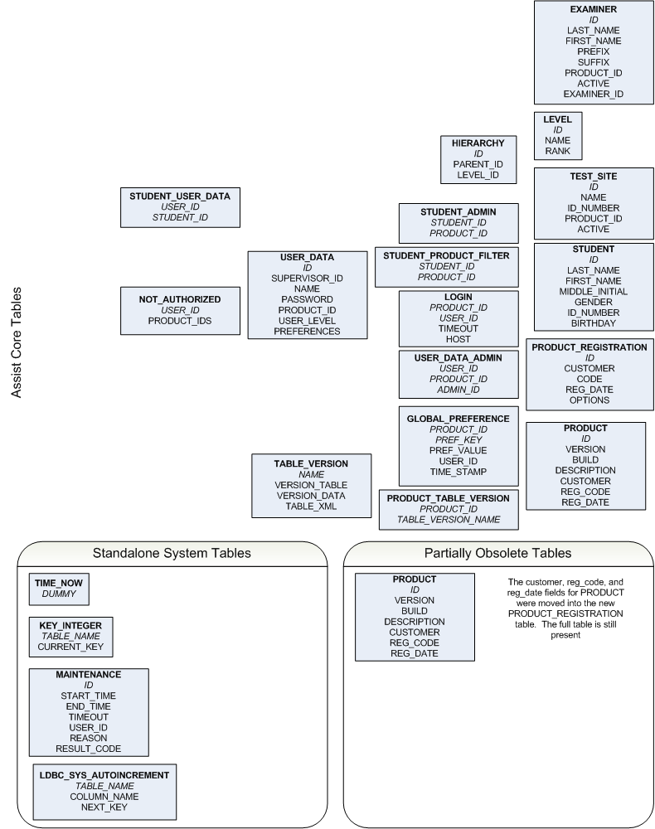

Accessing the HSQLDB GUI is accomplished by using one of several batch files. There are currently five, assist.bat, group.bat, keymath.bat, bess.bat, and ssis.bat. Assist.bat is used for all ASSIST products except the BESS, KeyMath, and SSIS. Each of these has their own. GRADE and GMADE utilize the group.bat file. There are two reasons for the number of files. The first is that the database location for each varies slightly. The files are preset to these locations. The other is to ensure that the proper version of the HSQLDB.jar file is used as some are on version 1.7.x and others are on 1.8.x. Using the incorrect HSQLDB.jar file can result in the database being unusable for the customer.

There are a variety of issues that may arise with these databases. Few of the root causes are known but in most cases, we have solutions that will allow for quick and easy resolution for the technician and ultimately, the customer. It is important to recognize which error is which before trying to dig through data or collecting the user’s data unnecessarily. Here are some tips and the steps to diagnosing database issues as well as how to repair and\or escalate the issues.

- It is imperative that you are aware of the time zone the user is in. As with most testing products, the birth date and test date are critical components. HSQLDB stores all dates with a time code that records the difference between the user’s location and UTC. If you are not using the same time zone as the user, this may throw off birth dates and test dates by varying degrees causing some records to invalidate or causing the system to duplicate records because it views the two as different. This is especially true with GRADE and GMADE, but should be considered with all applications.
- Errors with the database can occur in three locations: The properties file, the script file, or the data file itself. Each requires different actions and causes the database to react differently.
  - A properties file error manifests the same each time. When the user launches the application and it tries to connect to the database, they will receive the error:

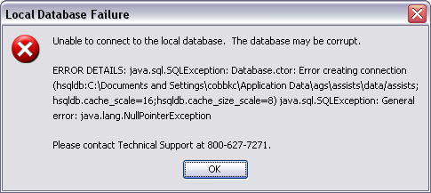

Resolution:

This error means that the properties file is blank and will need to be replaced. This is as simple as copying your assists.properties file from your computer to theirs. It does not matter whether they are on a Mac or on a PC as the file will be the same.

  - Script file errors can manifest in numerous ways. Currently in every case there is no solution that support can implement to repair the problem. Unlike the properties file, the values in a script file vary depending on the product being used and what has been entered into the system. It is important to gather as much information as possible before escalating a script file error. You will need to know the product(s) being used, the build number for each product, and the exact problem with the script file.
    - Always manually check for the products the customer is using. They may only call you for one application (i.e. BASC-2) but may actually have multiple products that are being affected. Navigate to the data location for the user and open the folder with the name of an application (i.e. basc, ktea, kabc, etc…). Inside each of these folders, is a logs folder. Here you will find an info.log file. This file contains the configuration information for the application. When opened in MS Word or another application more powerful than notepad, you will see information that is similar to the following:

Product: ktea Build: 37
Customer: Not Registered
System: x86 Windows XP 5.1
Java: 1.6.0_11

Preferences:
application_domain = user
update_url = ENC:http%3A%2F%2Fwww.agssupport.com%3A80%2Fautoupdate.php
update_repository = ENC:production
logs_url = ENC:http%3A%2F%2Fwww.agssupport.com%3A80%2Fuploadlogs.php
database_connection = ENC:C%3A%5CDocuments+and+Settings%5Ccobbkc%5CApplication+Data%5Cags%5Cassists%5Cdata%09Local+Database%09hsqldb%3AC%3A%5CDocuments+and+Settings%5Ccobbkc%5CApplication+Data%5Cags%5Cassists%5Cdata%2Fassists%09MBr%2BRUMfLOY%3D%090EFCT1uvAEM%3D%09true
update_interval = ENC:weekly
update_attempted = ENC:120808

The build number will be vital to the developer in working through the issue and this file will most likely be the only way to ascertain the build if the user cannot log into the application at all. Noting the java version being used can also be helpful for future troubleshooting. The remainder of the information may be useful if you have to remove the preferences and reset them so that you can remember where the user chose to put things the first time they ran the application. You will want to repeat this for all of the products so that you can know the build for each one to pass on to the developer.

    - Next, you need to ascertain the issue being faced. Two major issues can occur with the script file. The first is that it is completely blank. When you are dealing with a blank script file you will see the following error when the application attempts to connect to the database:

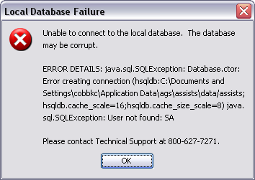

The key thing to notice here is the “User not found: SA” line above the technical support number. The script file contains the login information to the database so when the file is blank, the user not found message is a quick way to tell.

    - The other type of script file error you will face is when the one of the indices is incorrect. When this happens, you will see an error that resembles this when the application attempts to connect to the database:

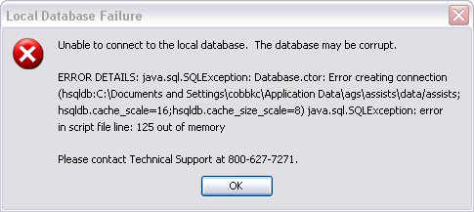

You may also see an error that gives you an ArrayIndexOutOfBounds exception that references a line in the script. This is also related to an index being out of synch.

Resolution:

Collect the user’s entire data folder and any info.log files that are appropriate. Send an email to adam.ganser@pearson.com alerting him that you have a corrupt database that requires a developer’s attention and request that a resource be named. Include the product names that are affected so that Adam can route the issue properly. When a resource has been named, transfer the data folder and info.log files that you have collected to the developer for resolution. Do not contact developers directly until they have been advised by Adam that they are assisting you.

  - Data errors come in several forms. While there is always the case of a user having entered something incorrectly, these are not errors that we generally resolve for them. Examples of this include an errant birth date after tests have already been entered. While it is possible to collect the user’s data, make the alteration on the back-end of the database, and return the data to them, this is considered too time consuming and out of scope for normal support functions. As an aside, the resolution for this is to have the user delete all tests that have been entered in for the student and make the adjustment themselves and then re-enter the tests. While this can be handled by us, it is a good way to help the users to remember how the software works and what limitations are in place. Data errors can be divided into three main categories.
    - Key Integer errors: These errors are related to an auto-incremented table tied to several user tables and one system table. The user tables common to all ASSISTs, GRADE, and GMADE are: Student, User Data, Examiner, and the Admin table for the application. User tables that are product specific are Level (PPVT & EVT and SSIS) and Teacher (Vineland Teacher Rating Form). The Maintenance table is the only system table tied to Key Integer and is common to all products.
      - Key Integer errors related to user tables will not prevent the user from being able to login to the application. Instead, a unique constraint violation error will occur when the user tries to save a record with a new value in the user table(s) with an issue. For example, if the Key Integer value for student is set at 32, but there are actually 40 students in the system, when the user tries to save the student information a unique constraint violation will occur as you see below:

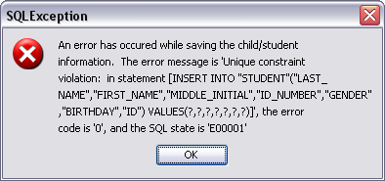

      - Key Integer errors related to the system table, Maintenance, will prevent the user from being able to login. In this case the following error will appear:

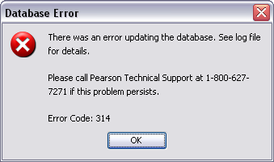

Clicking OK will result in the program asking you to please try and run the application at a later time and then the program will close. Regardless of which type of error you are receiving, the methodology to repair it is the same.

Resolution:

Collect the user’s entire data folder and place it in your data location. Using the proper batch file for the product in question, open the HSQLDB GUI to access the database. Run a select query on the Key_Integer table with the command [SELECT * FROM KEY_INTEGER]. Please note that the brackets are for documentation only and should not be used in the actual command. The system will return all rows and values currently in the table. Take note of what rows are present and their values. In many cases where there is one error, there may be others so all values should be noted. Take note as well if any expected user table rows are missing. Start with the first table listed and run a select query on that table. For example, [SELECT * FROM STUDENT]. Scroll down to the bottom of the table and compare the ID in the last record to the value you noted from Key Integer. If the values match, no action is needed and you can proceed to the next table listed in Key Integer. If the value in Key Integer is higher than the last row in the table, again, no action is needed. This can happen because of record deletions and will not cause a problem within the application. If, however, the value in Key Integer is lower than the last record you will need to run an update query to repair the value. Do this by using the following command [UPDATE KEY_INTEGER SET CURRENT_KEY = ‘value’ WHERE TABLE_NAME = ‘table_name’]. In this case value is equal to the correct numeric value from the last row of the table and table_name equals the table you retrieved the value from. Note that the single-quote is required and is not being used for documentation. After executing the statement, you should receive an update count of one. If you receive more than this, you have typed something incorrectly and may have to start over. Always work with a COPY of the user’s data folder in case you need a backup to start again! Repeat the process running select queries on the remaining rows in Key Integer to ensure that all values are correct. Once this is completed, use the shutdown command to close the database and then close the HSQLDB GUI. The issue is now repaired. You may also notice that rows are missing from Key Integer. If any of the tables listed previously are missing from Key Integer, you will need to run an insert query to add the proper values into the table. First run a select query on the table that is missing an entry and scroll down to the bottom to get the last row number. Then use the following command to insert the value [INSERT INTO KEY_INTEGER (‘TABLE_NAME’, ‘CURRENT_KEY’) VALUES (‘table_name’, ‘value’)] In this command table_name would be the name of the table that is missing and value would be the number of the last row in the table. Repeat this as necessary until all of the necessary rows are present. Use the shutdown command to close the HSQLDB GUI. The issue is now repaired.

    - Illegal attempt to update errors are another type of data error. These errors also come in two forms.
      - The first type of illegal attempt to update error comes when one product has update the database version after the program has been updated, but another product is too far behind in version to be on the same level. When the second application is launched, the system will try to reset the value and a message like the following will be displayed:

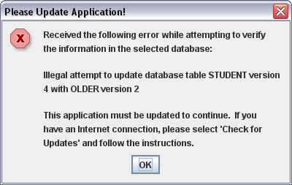

Another example of the same problem but without the illegal attempt message is:

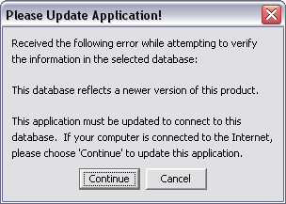

The first example occurs with older builds of the applications. As the error didn’t occur until it actually attempted to update the database. In the second example, the system attempts to verify the information in the database first and then determines if an update is needed.

Resolution:

In either case, the solution is to direct the user to www.agssupport.com/downloads.html. Here, they can download the most current Contents folder for the application and once this is placed in the proper folder the application will resume normal operation.

      - The second type of illegal attempt to update error has only manifested itself in the BASC-2 family of applications thus far. This issue will display the following error:

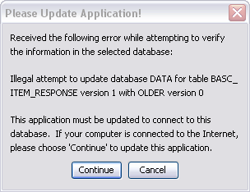

This issue cannot be resolved by updating the application to the latest build because in point of fact, it occurs after updating to the latest build due to an error in an unknown previous build.

Resolution:

Collect the user’s entire data folder and place it in your data location. Use the assist.bat file to open the database. Once the GUI is open, use the following command to repair the error: [UPDATE TABLE_VERSION SET VERSION_DATA = ‘0’ WHERE NAME = ‘BASC_ITEM_RESPONSE’]. You should receive an update count of one. If you do not, then you may have typed something incorrectly and may need to start again. Once you have received the update confirmation, use a Shutdown command to close the database and then exit the GUI. The issue is now repaired.

Login Issue:

There is another issue that can surface with the ASSIST platform as it relates to logins. If a user abruptly closed the application by ending the task or the process, the login information for the last user can get stuck and prevent the user from logging in when the application is re-launched.

Resolution:

Use the appropriate batch file to open the user’s database. Once the GUI is open, use the following command to repair the error: [DELETE FROM LOGIN]. Executing this statement will clear any entries currently in the login table. Use a Shutdown command to close the database and exit the GUI. The issue is now repaired.

Section Six

Client\Server

Several of our ASSIST products, as well as GRADE and GMADE, are sold with the capability to connect to a SQL Server database in a different location than the software is being used. While the software is still loaded locally, the database lives, and is maintained, independently from the user. This allows for multiple users to share the data for client management as well as reporting functions. It is important to mention that while only some of these products are sold in this way, all of these products are built with the capability. Only products that have been thoroughly tested, however, are authorized for sale to users. The products currently sold in this way are the BASC-2, KeyMath-3, PPVT-4/EVT-2/PPVT-III/EVT, GRADE, and GMADE. There are three areas related to client\server applications. The first is user pre-qualification, next is implementation, and finally support. Each of these will be covered in detail.

Client\Server Pre-Qualification Consult Process

Phase I – Making Contact

Phase I begins when notification is received that a client is interested in implementing a client\server application. Notification is received by email and contains the name, telephone number, and email address, if available, for the Program Administrator for the software within the user’s organization. In many cases, the name of the IT specialist will also be included. An email or a phone call is placed to the Program Admin to schedule the consultation and allow for re-routing to the proper personnel or gathering thereof within the user’s organization.

Phase II – Assessing the Customer

A variety of information needs to be gathered in order to properly pre-qualify a C\S user.

- Determine if the user has a supported version of SQL Server. Currently versions 2000 and 2005 are supported. We have two customers running in 2008 and to date there have been no issues. I bring this to the customers’ attention on the off chance they are running this version and are interested in trying it, with the understanding it has not been officially SQA approved and we cannot verify their results. The same can be said for SQL Server Express 2005 and 2008. These are free versions of SQL Server and should only be offered if the user does not have a fully licensed copy of SQL Server and the implementation is expected to be five users or less with no scaling up at a later date. If the user has an approved version proceed to step 2, if not the user is not pre-qualified for purchase.

- Determine the rough number of concurrent licenses the organization intends to purchase. If this number is unknown, an approximation will be needed to discuss the server’s hardware requirements which are as follows:

  - 10 or less users – Single CPU 1GHz or higher, 1GB RAM. No RAID configuration is recommended at this level. Standard SQL backup policies should be sufficient. A server which is under 50% of CPU utilization is recommended.
  - 11-25 users – Dual CPU 1 GHz or higher, 2 GB RAM. RAID 1, basic disk mirroring, is recommended along with standard SQL backup policies. A server which is under 30% of CPU utilization is recommended.
  - 26-50 users – Dual CPU 2 GHz or higher, 2 GB RAM. RAID 5 is recommended along with standard SQL backup policies. A server which is under 25% of CPU utilization is recommended.
  - 50+ users – Dual CPU 2 GHz or higher, 2 GB RAM. RAID 5 is recommended along with standard SQL backup policies. A dedicated server is recommended.

- Determine if the organization has appropriate bandwidth from all sites to the SQL Server. Anything less than T1 connections should be avoided, fiber is preferred for WANs.

- Ensure that the organization has the proper personnel on staff to administrate and maintain the software and the SQL server beyond the support provided by Pearson. Alert the user(s) that there should be two administrators named. The first is the IT specialist who will be responsible for data backups, hardware repair, and software updates, both for the client and the designated administrative copy of the software. The second is the Program Admin who will be responsible for user management and data management within the application. Users without the proper personnel (i.e. SQL DBA) should be evaluated for the appropriate skill set before being pre-qualified. This will require a level of knowledge that may be limited to specific representatives within our support organization.

- Determine whether or not the user’s workstations meet the minimum system requirements as defined by the user’s manual for the software. If they do not the user cannot be pre-qualified.

Phase III – Final status

Once you have determined the user has or has not met all requirements, inform the customer as to their status to purchase the software. If you are speaking with the IT specialist, ask that they connect with the referring administrator with the results of the call. If the user was pre-qualified, provide them with contact information to set an appointment for implementation when they are ready to proceed. Regardless of the user’s status, notification then needs to be sent to the Product Manager, and sales rep, that pre-qualification has been completed. Detailed results should be provided to both. Outlined should be the user’s configuration, expected usage plans, and whether or not they have been pre-qualified.

Client\Server Implementation Process

Implementation of the Client\Server software involves walking the user through creating the SQL Server database, creating the user login to the database, installing the administrative copy of the software, successfully connecting to the database to create the application tables, updating the software if necessary, and then final comments to the administrator on aspects to the software that they will need to manage. Also, recommendations for deployment to the workstations should be made unless this has already been accomplished by the user in advance. Finally, the boundaries of support offered by Pearson should be made very clear to the user to avoid confusion as to where the lines of responsibility fall.

WebEx or a remote connection client will be needed to ensure the implementation is completed properly. While you should be working with a network or database administrator for this step, it is always good to be able to look over their shoulder so that things are set appropriately and so that any questions can be answered as you go.

Step 1: Database Creation

Database creation varies based on the version of SQL Server being used, but only slightly. All examples shown will be for to SQL Server 2005 Express. These steps will also apply to the fully registered SQL Server 2000, 2005, and 2008, with the notable exception of a different interface name for SQL Server 2000. SQL Server Express 2008 will also utilize the same steps. Please note that the person you are working with MUST have administrative rights to the SQL Server in order to create a new database and user login for the database. In addition, if the user has multiple products, it is recommended, though not required, that each product have its own database. This is to prevent any downtime in all applications being caused by one and also prevents the need to restore a database for all applications when only one is having an issue. The trade-off to this is that no data will be shared between the applications. This decision should be left to the user.

The first step is to open the SQL Server Management Studio. For SQL Server 2000 this is called the Enterprise Manager. For the Express versions, it is the SQL Server Management Studio Express. This is NOT included by default with Express installations and the appropriate management tool may need to be downloaded from Microsoft. When opened, the server will request that the user login with their server credentials. Once they have logged in, the screen should resemble the image below:

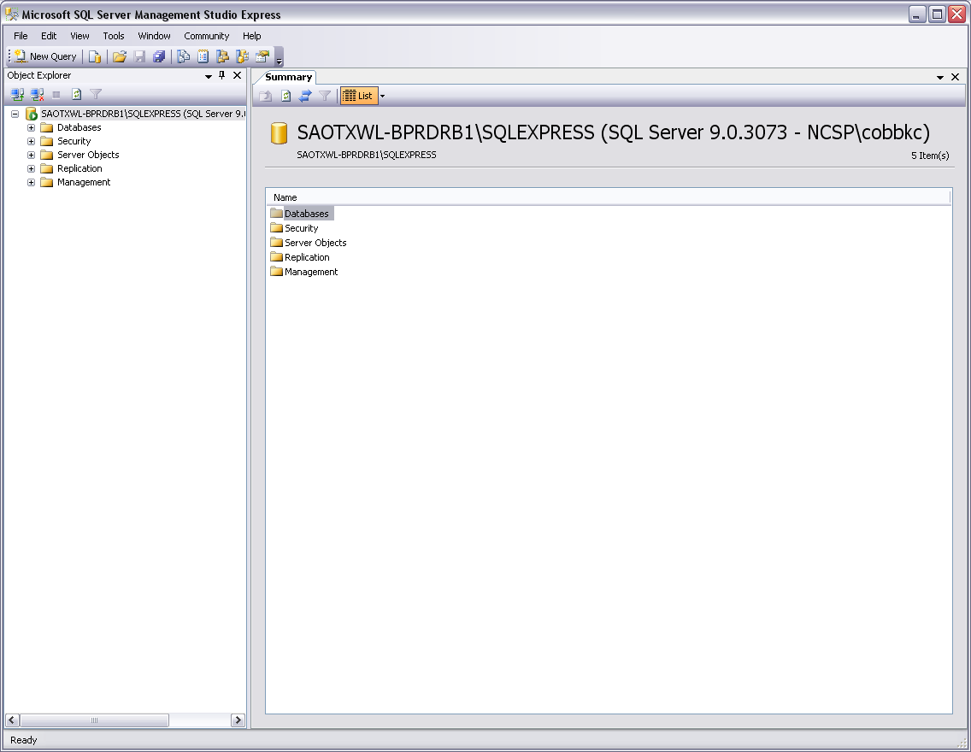

Once this screen appears, right click on the Databases option and select New Database. The screen should change to the following image:

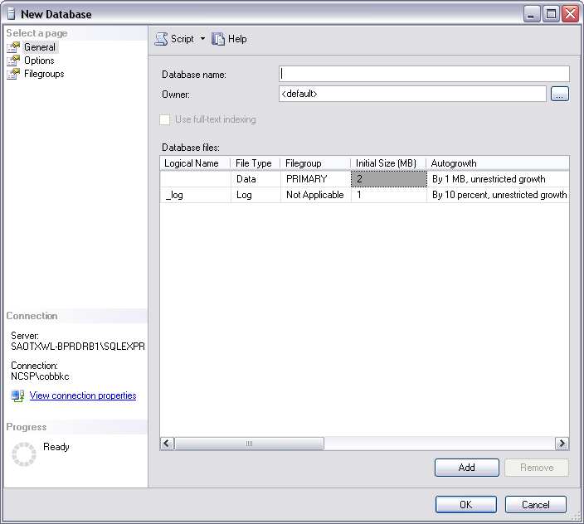

Have the user, or if you are remotely controlling you can do this yourself, name the database. This name can be whatever they would like, though it is generally recommended to use some variation of the product being used. Once the name has been added, click OK at the bottom of the screen and SQL Server will create a skeleton database with only the basic SQL system tables.

Next, have the user right-click on the actual server located above the Databases option and select Properties from the menu. The screen will change to the following image:

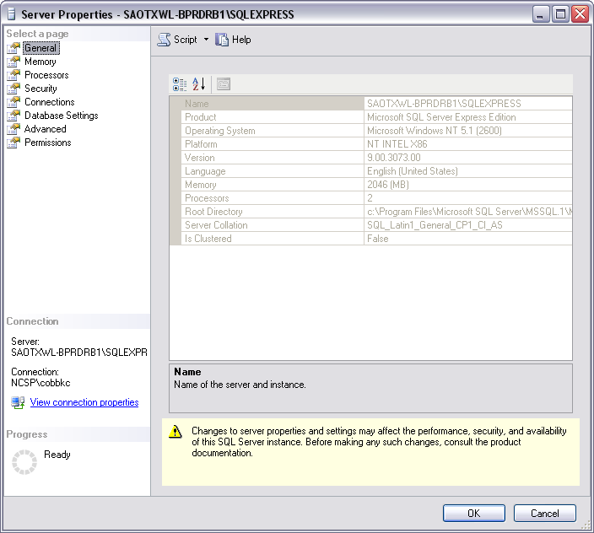

From here, click on the Security option. Your screen should now resemble this image:

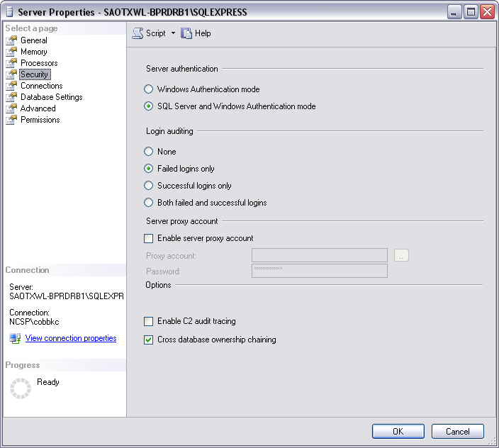

In most cases, Windows Authentication mode will be selected. Change the setting to SQL Server and Windows Authentication mode as shown in the image above. This is also known as mixed-mode authentication. Our software will not connect to the database using Windows Authentication so this step is imperative for proper setup. Once you have changed the property, click OK. This may require the SQL Server Service to be restarted. If the system is already set for mixed-mode click OK or Cancel to return to the main window.

Database setup has now been completed. Next we will setup the user login for the database.

Step 2: Database User Login Creation

Only a single user needs to be created for the database as all users of the software will use the same connection information to the SQL Server. However, it is important that this user be created using these steps to ensure proper connectivity.

From the main window, click the plus sign next to Security to display the various options contained within. Next, right-click on Logins and select New Login. Your screen will change to the following image:

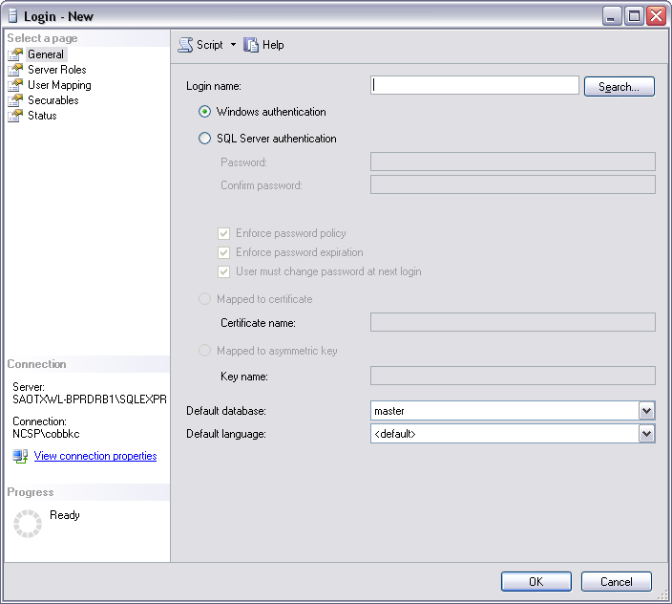

The login name can be anything that the user chooses, however, it is generally recommended to use some variation of the product being used. Select SQL Authentication and uncheck the Enforce password policy option. This will prevent password expiration and the user having to change the password. This is only for the connection to the database as individual user access will be controlled by our software. Enter in a password for the database connection. Then, click on the drop-down list for the Default Database option and choose the database that you created in step 1. DO NOT leave the setting at master as this can cause complications and in some cases can result in the need for a reload of the SQL Server. One this has been completed click on the User Mapping option to be presented with the following screen:

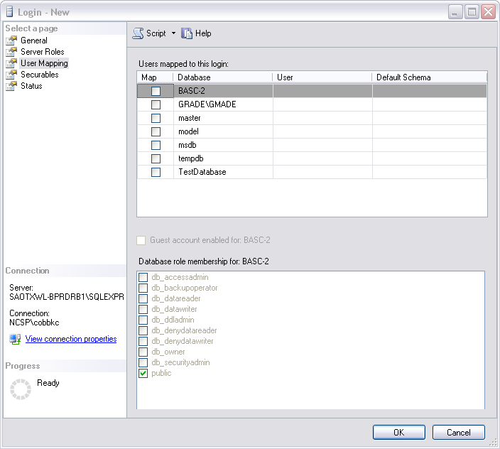

Select the database that you created in step 1 and then click the db_owner option at the bottom of the screen. Click OK to be returned to the main menu.

User login setup has now been completed. At this juncture, you will want to advise the administrator that they will need to setup any back-up or logging policies for the database. This does not fall within the scope of assistance provided by our organization as each user site will have individual policies for this. In addition, you will want to inform the administrator that the software will be attempting to connect to the database on the default SQL port of 1433. In registered versions of SQL Server this should already be set unless it has been changed by the administrator. In SQL Server Express this may need to be changed manually using the SQL Server Configuration Manager. If the port has been changed to something other than 1433 this is acceptable, as long as the port is known. If the user is not sure, the default port is almost always correct. You should be able to exit the Management Studio\Enterprise Manager at this point, as it should not be needed for the final steps of implementation.

Step 3: Installing the software and connecting

The next step is to install the “administrative” copy of the software. This is the same software that will need to be loaded on each of the client machines that will connect to the database. What makes this the administrative copy is that it is a) installed on either the server directly or an administrator’s computer and b) it will be this copy of the software that will be used to update the software. Installation of the software is the same as it would be for a normal local implementation with no variances. The same concerns with Java versions, etc… should be taken as they would be with any other install. Once the installation is complete, launch the software. You will be taken through the same steps regarding preference storage, All Users or Only This User, and then to the database location window as shown in the image below:

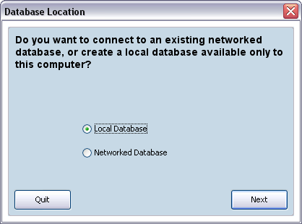

Select Networked Database and click Next. Your screen should change to the following:
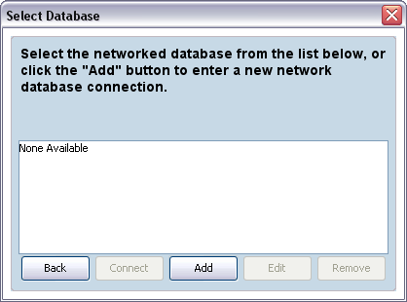

Click the Add button to setup the connection to the database. Your screen should change to the following:

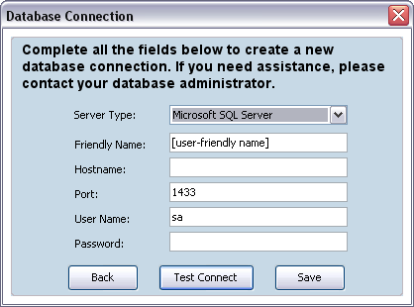

The Server Type property is by default set to SQL Server so no change should be made to this option. For the Friendly Name property, this can be anything the user wants to call the connection. It can be the same as the database name, or completely different if the user so chooses. The Hostname property can either be the IP address to the server or the actual name of the server. In some cases, if one doesn’t work the other will. In other cases it is completely interchangeable. If possible use the server name first and then if that fails, resort to the IP address. The Port should be the default 1433 unless the user has designated a different port. In this case, enter the user designated port into the field. User Name and Password should be the user login and password that you created for the database. Each client connecting to the database will use this login information to connect. Once this has been completed, click Test Connect. If the connection is successful, the following dialogue will appear:

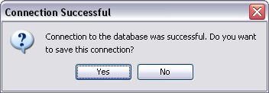

Click Yes to save the connection and you will be returned to the Select Database window with the database now listed. Click on the database to highlight it and click connect. The software will now connect to the database and create all of the tables that are needed for the software to function properly.

If the connection is not successful, the following dialogue will appear:

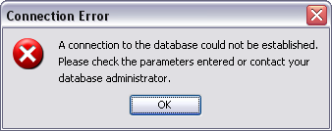

Click OK and re-examine your settings. This may involve changing from the server name to the IP address, it could be incorrect login information, or it could be using the wrong port. Modify the settings until you get a successful connection and are able to save.

Once the tables have been created the software will either prompt the user for their Customer Name and Activation Key or present a dialogue like the following:

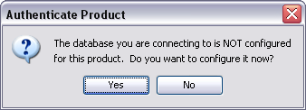

Click Yes on this dialogue to be presented with the fields to enter the Customer Name and Activation key which will control which features they have access to and how many concurrent connections to the database they are allowed. Once this information is entered and saved, there will be no need to enter this information again with subsequent client installations unless the database is deleted with no chance for restoration.

Finally, the user will be prompted to login with the default user name and password for the software, which are “admin” and “safety” respectively sans the quotes. Once the user has successfully logged in, they should be prompted to check for updates. If the user is able to complete the check, then update the software or not as appropriate. If they are unable to complete the check, due to a firewall or proxy server, then click Help, About in the menu to determine if an update is needed. If an update is needed, manually update the software and then advise the admin how to replicate the process for the client machines. You will need to advise the admin on this process regardless of the need for an update at the time if they are unable to do automatic checks. If an automatic update was successful, advise the admin that each client will be prompted to update when attempting to connect. It is also important to advise the admin to change the password to the ‘admin’ login. This login is the only one capable of updating the software and as such should be protected from users. If a user is logged into a local database using the ‘admin’ login and switches to the network database and the passwords match, the user will not be prompted to login again but instead, will automatically be logged in as that user. Once the password is changed this will prevent this from happening. Also, while other passwords are not character masked, the ‘admin’ login information is only viewable when logged in as that user.

Client\Server Support

Once you have completed all of the previous steps successfully, it is time to advise the administrator as to how support works for these products. As a general rule, support for a product using the client\server model is no different than supporting a local implementation. The software functions the same and behaves the same and as such will experience many of the same issues. There are, however, a few differences that exist in how certain issues will manifest themselves or how they are corrected.

Unable to connect to a previously functional connection

If a user is unable to connect to a previously functional connection, then something has to have happened on the server or network side to make this so. Either a) the server name and\or IP address has changed, b) the database has become corrupted or is no longer present, c) the user name and\or password has changed, d) the SQL Server service needs to be restarted, or e) the user’s network is having connectivity issues. If “a” or “c” are true, then this can be remedied by editing the existing connection with the new information. An administrator will not be required to make this change. If “b” is true, then an administrator will be needed to rebuild or restore the database. If “d” is true, then an administrator will be required to stop and restart the service on the server. If “e” is true then an administrator will be needed to repair the connectivity issue at either the site or the server. Once this is completed the user should be able to resume connection to the database without issue.

User gets an error that they are already logged in

As with the local version of this error, this can occur because the connection to the database was abruptly severed and the database is holding onto the login. The solution to this is to open the Management Studio\Enterprise Manager and go to the query analyzer. From here select the proper database to work with and use the command [SELECT * FROM LOGIN]. This will allow you to see all of the users logged into the system at the time. If only one user is displayed and it is the user having the issue, then the command [DELETE FROM LOGIN] will be sufficient to resolve the problem. If, however, more than one user is displayed, you will need to add a WHERE clause to specify which user to delete from the system so as not to disrupt other users. You can use either the user’s ID or Name to make this specification. It is also possible that this is not an error but that another user is actually using the login to connect. In this case, the network administrator will need to track down the IP address currently connected to the database and either ask them to log out or ask the user to wait until the other user is done or create a new login in the software.

Aside from these two issues, there are no other specific problems that users will face with the client\server model that fall within our support umbrella. Permissions, java versioning, etc… will behave and be resolved in the same way that was described in those sections of this manual for local implementations. Some of our products will experience a degree of latency and this is being looked at for resolution. It is important that the administrator understand that database and site specific connectivity issues are outside of our area. While we can assist with getting clients installed and connected to the database, and we can answer general questions on how to resolve these issues, we cannot support their network or their SQL Server environment. This is another reason it is so critical that users be pre-qualified to purchase this version to ensure their support structure is adequate to handle the issues that we do not.

Conclusion

This manual is as complete a guide to the current ASSIST platform, as well as the older and varied programs that exist, as is possible today. Does that mean that there were not things left out? Or perhaps we have created a manuscript that solves all? No, of course there were things omitted and as such not all problems will be so straightforward. This manual is a guide to assist you in understanding the most common issues that will be faced and to give some insight into the ways to resolve them. In the end, this is a living document and will need to be updated constantly to ensure it keeps pace with our users. There are a million ways to run our software and a million configurations to run it on. This manual combined with your own skills and other resources that are available to you should get you through most of the bumps in the road. And for those issues that it doesn’t cover, you just found a new problem/resolution to contribute! These contributions will prove vital to both yourself and new representatives that join the team. It is through this continuing commitment and contribution that we provide real value to our company and ultimately, to our customers.

