Notes on TEA-Ch2 Windows Installer
Our development team, Ounce Technology, has rewritten our desktop TEA-Ch2 app to be more efficient as well as signed it with a new certificate. It may take up to 2-3 weeks for a new certificate to build up a reputation. Until that time, Microsoft Defender SmartScreen tries to prevent executing the file, detecting it as an "unrecognized app”.
In the meantime, to proceed with the installation when you receive a Microsoft Defender SmartScreen warning message, click on “More info”:
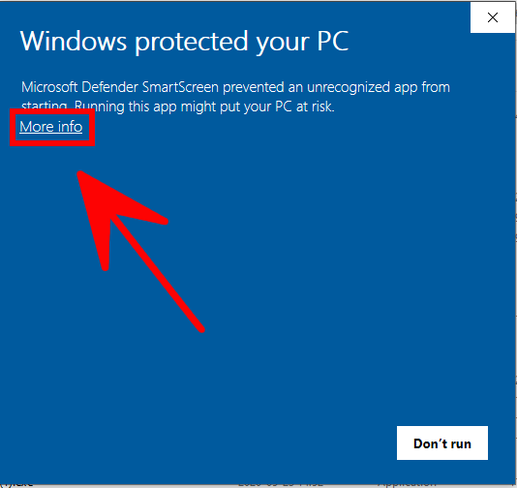
Then click on “Run anyway”.
